National Library of Australia

APS Net Zero by 2030

**Emissions Reduction Plan 2024**

Contents

Acknowledgement of Country 4

Accountable Authority Sign off 5

Emissions Reduction Plan 6

Purpose 6

Net zero greenhouse gas emissions 6

Governance and reporting 6

The National Library’s operational context 6

Property 7

Parkes Building 7

Hume Repository 8

APS Net Zero 9

Baseline emissions 10

Engagement 10

Emissions reduction targets 11

Priorities and actions 11

Appendix 1 – Environmental Action Plan 2024–2030 12

Background 12

The environmental action plan 12

APS Net Zero Emissions by 2030 Policy 12

Baseline emissions 13

Emissions category – ‘Other’ 14

Reducing our emissions – the baseline 15

Emissions Reduction Planning 15

Attachment A – Environmental Action Plan 2024–2030 17

NATIONAL LIBRARY OF AUSTRALIA ENVIRONMENTAL ACTION PLAN 2024–2030 18

Version History

|  |  |  |  |
| --- | --- | --- | --- |
| Date | Reviewed/ Actioned By | Version | Action |
| July 2024 | Director, Building Futures, Property and Sustainability | 1 | Revised draft Plan |
| July 2024 | Assistant Director-General, Property and Sustainability | 2 | Reviewed draft final Plan |
| August 2024 | Executive Review | 2 | Reviewed final draft Plan |
| August 2024 | Chair, National Library of Australia Council | 2 | Sign final Plan |

# Acknowledgement of Country

The National Library of Australia acknowledges Australia’s First Nations Peoples – the First Australians – as the Traditional Owners and Custodians of this land and gives respect to the Elders – past and present – and through them to all Australian Aboriginal and Torres Strait Islander people.

# Accountable Authority Sign off

The Australian Government released the Net Zero in Government Operations Strategy in November 2023, setting out the overall approach and action required by Commonwealth entities to achieve the APS Net Zero 2030 target.

The Net Zero in Government Operations Strategy represents a strong commitment by the Australian Government to lead by example on emissions reduction and contribute to the decarbonisation of Australia’s economy.

The National Library is committed to the achievement of the Government’s APS Net Zero 2030 target. The National Library is following the APS Net Zero 2030 target in full, as per the Net Zero in Government Operations Strategy.

This Emissions Reduction Plan describes the priorities and actions the National Library is taking to reduce our operational emissions and contribute to the APS Net Zero 2030 target.

# Emissions Reduction Plan

## Purpose

The National Library is responsible for managing and implementing emissions reduction initiatives set by the Australian Government’s [Net Zero in Government Operations Strategy](https://www.finance.gov.au/government/climate-action-government-operations/aps-net-zero-emissions-2030) (the Strategy) developed by Department of Finance. The Strategy sets out the Australian Government’s approach to achieving net zero greenhouse gas emissions from its operations by 2030 and the reinstatement of public emissions reporting.

The goal of this Emissions Reduction Plan is to provide a pathway for the National Library to contribute to the achievement of the APS Net Zero 2030 target through emissions reduction activities. This plan encompasses existing and new priorities and actions within the National Library to reduce emissions.

This Emissions Reduction Plan has been completed in accordance with the Strategy, associated guidance and reporting standards for annual emissions reporting.

## Net zero greenhouse gas emissions

APS Net Zero 2030 is the target set by the Australian Government to achieve net zero greenhouse gas emissions from government operations by the year 2030. It includes scope 1 and scope 2 emissions from activities in Australia and its territories, as described in the Strategy.

The APS Net Zero 2030 target applies at the aggregate level to non-corporate Commonwealth entities and generally covers the entirety of the entity’s organisation. From an organisational perspective, this means minimising the greenhouse gas emissions that are within our control.

## Governance and reporting

Progress against actions identified within this Emissions Reduction Plan, and any additional measures adopted, will be included in our annual reports. This, combined with annual emissions reporting, will be used as a measure of the National Library’s progress towards reducing its emissions.

As part of the Net Zero in Government Operations Annual Progress Report, the Department of Finance will aggregate these measures to provide whole-of-Australian Government emissions reporting.

## The National Library’s operational context

The National Library is one of several agencies within the Department of Infrastructure, Transport, Regional Development, Communications and Arts portfolio.

The National Library’s role, as defined by the *National Library Act 1960*, is to ensure that documentary resources of national significance relating to Australia and the Australian people, as well as significant non- Australian library materials, are collected, preserved and made accessible either through the National Library itself or through collaborative arrangements with other libraries and information providers.

The National Library of Australia is a world-leading and respected custodian of Australia’s published, written, oral, visual and digital heritage. We ensure Australian culture and knowledge is sustained for all Australian people, now and in the future.

The National Library’s vision is to connect all Australians with national collections, enriching conversations about who we are and our place in the world. We hold a massive and incredibly diverse collection exceeding 10 million physical items, currently occupying 273 shelf kilometres (LKM). Physical items include those made from paper, metal, film and sound recordings, paintings, fabric, ceramic and furniture.

Under the *National Library Act 1960*, the National Library has a legal obligation to ensure that documentary resources of national significance relating to Australia and the Australian people, as well as significant non- Australian library materials, are collected, preserved and made accessible.

The National Library also has obligations under the *Copyright Act 1968* to acquire legal deposit copies of all works published in Australia, it receives donations and is offered opportunities to acquire items. On average, the physical collection grows by 2−2.5 LKM per year.

The National Collection also includes digital material, currently comprising 2.96 petabytes. In 2023−24, digital items made up 61% of the material collected.

### Property

The National Library owns and manages two buildings in Canberra:

* The National Library building at Parkes Place, Parkes, ACT.
* The Repository, corner of Tralee Street and Monaro Highway, Hume, ACT – offsite collection storage facility.

The National Library also leases the following spaces:

* Hume Annexe, 64 Shepard St, Hume, ACT – offsite collection storage facility.
* National Archives of Australia, Mitchell, ACT – a portion of the building is leased for offsite collection storage until June 2026.
* 6 National Circuit, Barton, ACT – 3-year offsite office accommodation lease during ongoing building works at the main building.

### Parkes Building

The Parkes (ACT) building is entered in the Commonwealth Heritage List [ID. No. 105470] under the heritage provisions of the *Environment Protection and Biodiversity Conservation Act 1999* (EPBC Act), for its historic heritage values.

The Parkes (ACT) building currently incorporates the following uses:

* Specialised collection storage – the building houses the most significant and high usage collection material. Items are stored in a variety of ways, on open shelving, in cabinets and compactus. Storage spaces are known as ‘stacks’ and occur throughout the building on every floor. Each stack has different environmental conditions relating to the requirements of the items housed in it (ie. the Lakeside stack on Lower Ground Floor 2 (LG2) is passive, whereas the Maps stack on Lower Ground Floor 1 (LG1) is climate controlled).
* Public spaces – events and exhibition spaces, and collaboration spaces.
* Retail spaces - bookshop, café.
* Reading room spaces – main reading room accessible to all the community, and the special collections reading room available to researchers.
* Staff workspaces – general office fit outs; photographic and digitisation studios; preservation lab; exhibition workshop; kitchenettes on each floor; Oral History recording studio (sound proofed booths with specialised recording equipment).
* Back of house – commercial kitchen for café; 5 general lifts and one book lift; plant and utility service areas; digital, IT server room, and comms network spaces; non-collection storage spaces; quarantine rooms; loading dock; cleaners’ office, maintenance contractor's office/workshop; security control centre; cool/cold store (for collections).

The occupied area of the building is 43,860m2, broken up by function as follows:

|  |  |  |
| --- | --- | --- |
| Function | Area (m2) | Percentage of building (%) |
| Amenities | 358 | 1 |
| Circulation | 3,778 | 9 |
| Core facilities | 2,441 | 6 |
| Exhibition | 694 | 2 |
| Workspace | 9,088 | 21 |
| Public | 4,681 | 11 |
| Retail | 524 | 1 |
| Services/plant | 2,725 | 6 |
| Special function | 859 | 2 |
| Collection storage | 16,680 | 38 |
| Non-collection storage | 2,032 | 5 |

The primary use of the main building is for storing collections which are high use, highly valuable and/or significant, and generally require climate-controlled conditions (either temperature, or temperature and humidity). It also provides staff workspaces and access to the public.

### Hume Repository

The Hume Repository was constructed in 2004–2005, opening in August 2005. The primary use of the facility is for storage of collections. It also has a small office, kitchen, toilets, plantroom, utilities area, and loading dock in addition to the large storage area. The total area is 3,740m2.

An extension of the Hume Repository will be built in 2024–2025. The design of the extension module includes opportunities for energy savings and other measures (i.e. provision for installation of solar panels) which will assist the National Library to meet Net Zero targets. The extension area will be 1,005m2.

The Repository, and the Hume Annexe, store collections which are medium or low use, and do not generally require climate-controlled conditions. Although the Repository has a Heating Ventilation and Air Conditioning (HVAC) system, it was turned off in 2012 during a 12-month trial looking at passive conditions for collections. It has not been turned back on.

### APS Net Zero

The National Library has already commenced its net zero emissions pathway in line with the direction set in the Strategy.

The National Library has been reviewing and managing its climate controls for collections since 2001, when a review of international standards and practices resulted in the development of the first Environmental Management Plan. This plan saw us tighten our climate control parameters at the time in line with what had become the unofficial standard of 20⁰C ± 2⁰C and relative humidity (RH) of 50% ± 5% for storing paper- based collections.

In 2012 the National Library moved towards passive climate control by implementing the 12-month trial at the Repository. In that period, conditions in the building were generally maintained at averages of around 16- 20⁰C and 48% RH, even during a month which saw average outside temperatures of over 30⁰C, and one week of temperatures over 35⁰C. There were energy savings of 345,237 kilowatt hours (kWh) or $40,000 over the 12-month period. One of the key findings was that paper collections buffer conditions and improve building thermal mass.

Passive controls are still maintained at the Annexe and Repository, and we continue to review and manage climate controls in these two buildings and in the main building.

In 2012 the National Library also commissioned a feasibility report on installation of solar photovoltaic (PV) panels at the Repository. Although deemed feasible, this was not progressed. Re-visiting solar PV for the Repository and the main building are activities in the Environmental Action Plan.

Other actions completed or in progress include:

* Purchasing renewable electricity through the ACT Government.
* Engaging a consultant to assist in scoping requirements for a compliant response to APS Net Zero and to update our action plan, baseline our carbon footprint, design an actionable program to meet APS Net Zero requirements (the environmental action plan), and enhance the environmental management system.
* Continuing to progress two major building infrastructure projects aimed at improving building performance and energy efficiency in the Parkes (ACT) building:
  + Heating Ventilation and Air Conditioning (HVAC) Upgrade Phase 1 stages 1–3: replace and refurbish the most pressing end of life HVAC plant and equipment.
  + Heritage Windows Replacement Project: replacement and refurbishment of aging heritage windows to remediate loss of conditions and leaks on all building facades.
* Completing the copper roof replacement project, which gave us an opportunity to install insulation in the ceiling cavity and roof space above Level 4 in the Parkes (ACT) building and add two additional layers below the copper roof sheets – a waterproof membrane and a ply sub-structure – to further improve the thermal efficiency of the building.
* An ongoing program of changing over old fluorescent globes to LEDs in the buildings.

The nature of our operation means that collections will continue to grow, physically and digitally. Our online presence will continue to increase through outreach programs as well as providing access to digital collections through our online catalogue, Trove. There is no current baseline emissions data for our digital storage but, through the installation of Smart Meters on the new Computer Server Room in early 2024, we will start to capture and report this data.

There is also no baseline data at this time for digital storage, legal deposit (which is now predominantly digital), or for the National Collection, but this will be a focus in the next 2 years, allowing us to add to the data provided in our annual reports over time.

The National Library expects there will be changes to our physical buildings over the next 10 years, through projects coming out of the Building and Collection Storage Master Plan or the Strategic Asset Management Plan, and these will provide opportunities to address environmental sustainability by incorporating emissions reduction measures. The challenge of reducing emissions in a heritage building is not underestimated.

There will also be changes to the way we work, arising from the COVID-19 pandemic and Australian Government workplace policies, which will affect our emissions and for which the data will need to be captured. Digital activity will increase in the cyber security and Artificial Intelligence spaces.

The challenge for the National Library will be in offsetting the growth of collections with their complexity of storage requirements, along with digital storage and performance against the requirement to reduce emissions to zero by 2030.

### Baseline emissions

Baseline emissions are a record of greenhouse gases that have been produced in the past and were produced prior to the introduction of any strategies to reduce emissions. The baseline emissions from financial year 2022–23 are the reference point against which emissions reduction actions can be measured.

The baseline emissions for this plan focus on scope 1 and scope 2 emissions, consistent with the APS Net Zero 2030 target. Electricity-related emissions were calculated using the location-based method. The complete 2022–23 greenhouse gas emissions inventory tables for the National Library are presented in our 2022–23 annual report. It should be noted that the scope 1 emissions for natural gas in the Annual Report were incorrect, and therefore the total scope 1 emissions figure is also incorrect. Corrections are included in the 2023–24 Annual Report.

|  |  |
| --- | --- |
| Baseline year | Financial year 2022-23 |
| Scope 1 emissions | 392.562 tCO2e |
| Scope 2 emissions | 3,340.868 tCO2e |
| Total emissions | 3,733.43 tCO2e |

It is noted, however, that requirements for the 2023–24 Greenhouse Gas Emissions Inventory cover scope 1, 2 and 3 emissions. The Emissions Inventory will be included in the National Library’s Annual Report.

## Engagement

In the development of this plan the National Library has been working with the Department of Finance:

* Climate Action In Government Operations – to ensure that this plan aligns with the Net Zero in Government Operations Strategy and the Commonwealth Climate Disclosure requirements.
* Fleet Team – to discuss options associated with low emissions vehicles.

## Emissions reduction targets

The National Library is following the APS Net Zero 2030 target in full, as per the Net Zero in Government Operations Strategy. The target covers the entirety of our entity’s operations within Australia and its territories for scope 1 and scope 2 emissions, as described in the Strategy.

## Priorities and actions

For the National Library to contribute to the achievement of the APS Net Zero 2030 target, targeted action on existing emissions reduction measures and the introduction of further or new measures is required. The National Library’s priorities and actions to meet Net Zero are set out in Appendix 1 – Environmental Action Plan 2024 - 2030.

# Appendix 1 – Environmental Action Plan 2024–2030

## Background

### The environmental action plan

The Library’s Environmental Management System (EMS) was developed in 2010 and comprises a suite of templates and guidance documents for management, monitoring and auditing of environmental management practices, as well as reporting.

The existing Environmental Action Plan (Plan) was developed in 2014, and a number of activities have been delivered:

* a three-bin system for grading kitchen waste.
* added mobile phone recycling and mixed light recycling.
* replaced call slip printers with more efficient equipment.
* reduced the fleet to 1 vehicle.
* improved the facilities available for cyclists.
* continued to maintain passive conditions for offsite storage.
* implemented an ongoing lighting upgrade program, to reduce energy usage and improve efficiency.

Since 2014 several environmental policies and measures have been introduced by the Australian Government, most recently the APS Net Zero by 2030 Policy.

### APS Net Zero Emissions by 2030 Policy

The APS Net Zero Emissions by 2030 Policy (Policy) has two parts. The Australian Public Service (APS) must:

* reduce its greenhouse gas emissions to net zero by 2030; and
* transparently report on its emissions from the latter half of 2023.

The Policy includes all Scope 1, 2 and 3 emissions attributed to the APS (see Figure 1).

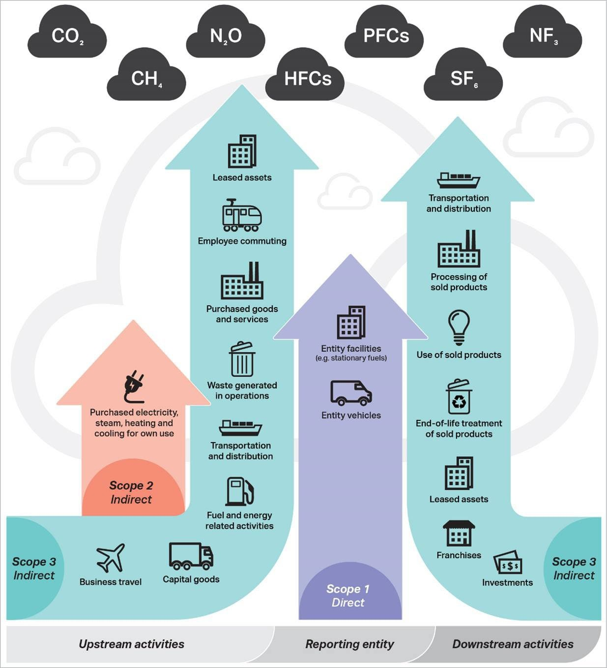

Figure 1: scope 1, 2 and 3 emission categories

The Net Zero in Government Operations Strategy (Strategy) describes the approach for implementing the Australian Government’s commitment to achieve net zero in government operations by 2030. The Strategy was launched on 28 November 2023. Under the Strategy, the APS Net Zero 2030 target only covers scope 1 and 2 emissions. Decisions on scope 3 will be made in the future.

However, requirements for the 2023–24 Greenhouse Gas Emissions Inventory cover scope 1, 2 and 3 emissions. The Emissions Inventory will be included in the National Library’s Annual Report. To report on scope 3 emissions, the National Library will have to collect this baseline data.

### Baseline emissions

Baseline emissions are a record of greenhouse gases that have been produced in the past and were produced prior to the introduction of any strategies to reduce emissions, and the baseline emissions for this plan focus on scope 1 and scope 2 emissions, consistent with the APS Net Zero 2030 target. Electricity- related emissions were calculated using the location-based method. The complete 2022–23 greenhouse gas emissions inventory tables for the National Library are presented in our 2022–23 annual report.

In 2023–24 the National Library commissioned Lucid Consulting (Lucid) to update the EMS, establish a carbon footprint baseline, and design an actionable program to meet APS Net Zero requirements to assist the National Library to meet the Australian Government’s environmental commitments.

An assessment of the National Library’s annual emissions was undertaken by Lucid in 2023, following consultation with key Library stakeholders including Facilities, Capital Works, Collection Care, Technology Operations and Finance teams using the following data:

* Consumption data from utilities, including energy and water.
* Waste disposal and diversion from landfill reports.
* Audit of large refrigerant-containing equipment.
* Staff travel records.
* Spend data by financial account code.

Figure 2 shows existing emissions breakdown per category per scope in tonnes of carbon dioxide (t CO2).

Scope 1: Gas & Fossil Fuels 813 t CO2, Refrigerants 88 t CO2, Transport 171 t CO2.
Scope 2: Electricity 3,615 t CO2.
Scope 3: Water 27 t CO2, Waste 88 t CO2, Other Procurement 4,056 t CO2

Figure 2: emissions breakdown per category per scope

We can be confident that data for categories like electricity, waste, fuel and water is relatively well quantified through utility bills or waste disposal certificates. However, the category of ‘Other’ has a low level of data quality and more work needs to be done in this space.

### Emissions category – ‘Other’

Procurement data has been broken down into categories of emissions, using the financial account code as an indication of the type of goods or services being procured.

Generic emissions as *kilograms of carbon dioxide (CO2) per $* (kCO2$) have been assigned to each account code to generate this data. This is considered a low-quality data source, and assessment and reporting on Scope 3 emissions will be improved over time as further advice from the Australian Government is provided.

Figure 3 shows the percentage of emissions calculated for each account code in 2023 when establishing the carbon emissions baseline.

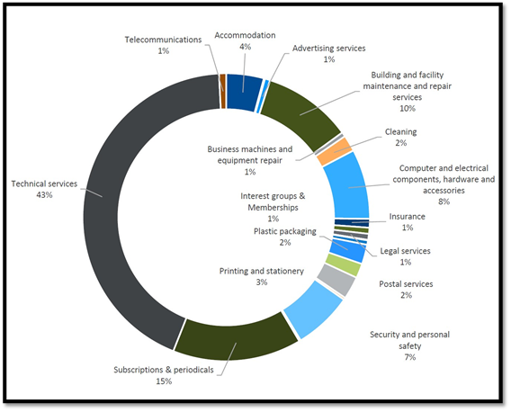

Figure 3: percentage of emissions calculated for each account code

The sub-category of ‘Technical Services’ covers contractors/labour hire, capitalised contract costs, and consultants.

The sub-category of ‘Subscriptions and periodicals’ covers:

* Subscriptions – Retrospective.
* Subscriptions – Print.
* Subscriptions – Physical format electronic (CD-ROMs etc).
* Serials – Legal Deposit.
* Subscriptions – eResources.
* Software Maintenance, Subscription, License Fees.

Collection items which come to the National Library through Legal Deposit can be either physical or digital. Further work in understanding the emissions from these deposits and collecting baseline data is required so we can better quantify the emissions and improve our reporting.

Similarly, more research and data collection on digital storage is required so we can establish baseline emissions and identify suitable reduction activities, or ways of offsetting increases in emissions from digital storage and our online digital presence through greater reductions in other categories.

The current total of 10 million physical items in the National Collection comprises paper, metal, film and sound recordings, paintings, fabric, ceramic and furniture. Each of these types has different baseline emissions, and quantifying each type so that emissions can be calculated will require significant effort; however, it will help us identify where further gains in emissions reduction can be achieved.

Donations and acquisitions can be paper or other materials, or a combination of materials in the case of an entire single collection. Collecting the baseline emissions data for these will be another body of work to be done in the next 2–3 years.

### Reducing our emissions – the baseline

Figure 4 shows the indicative impact that various activities are expected to have on the overall emissions of the National Library, reducing our emissions by 2030 from 8,858 t CO2 to 2,584 t CO2 and achieving around 70% reduction in emissions by 2030. The remaining emissions will need to be offset until such time as reduction measures are identified and implemented.

Achieving more than 70% reduction in the National Library’s total emissions amount is possible during the next 7 years as the Australia Government’s advice on emissions reduction is refined, the industry’s understanding of greenhouse gas emissions and technology to reduce emissions matures, and we continually review and assess categories such as procurement, capital works, and embedded carbon in the Parkes (ACT) building.

### Emissions Reduction Planning

In 2024 the Australian Government released further advice on emissions reduction, including a template for emissions reduction plans (ERP) for use by agencies to outline how they will meet the targets. The National Library prepared an ERP using the recommended template (Version 2.0 dated June 2024).

The Environmental Action Plan is an Attachment to the ERP and sets out the detailed activities the National Library will undertake per category, including the targets outlined in the APS Net Zero Strategy, to reduce its emissions by 2030 (Attachment A).

The ERP and environmental action plan demonstrate how the National Library will meet the APS Net Zero requirements.

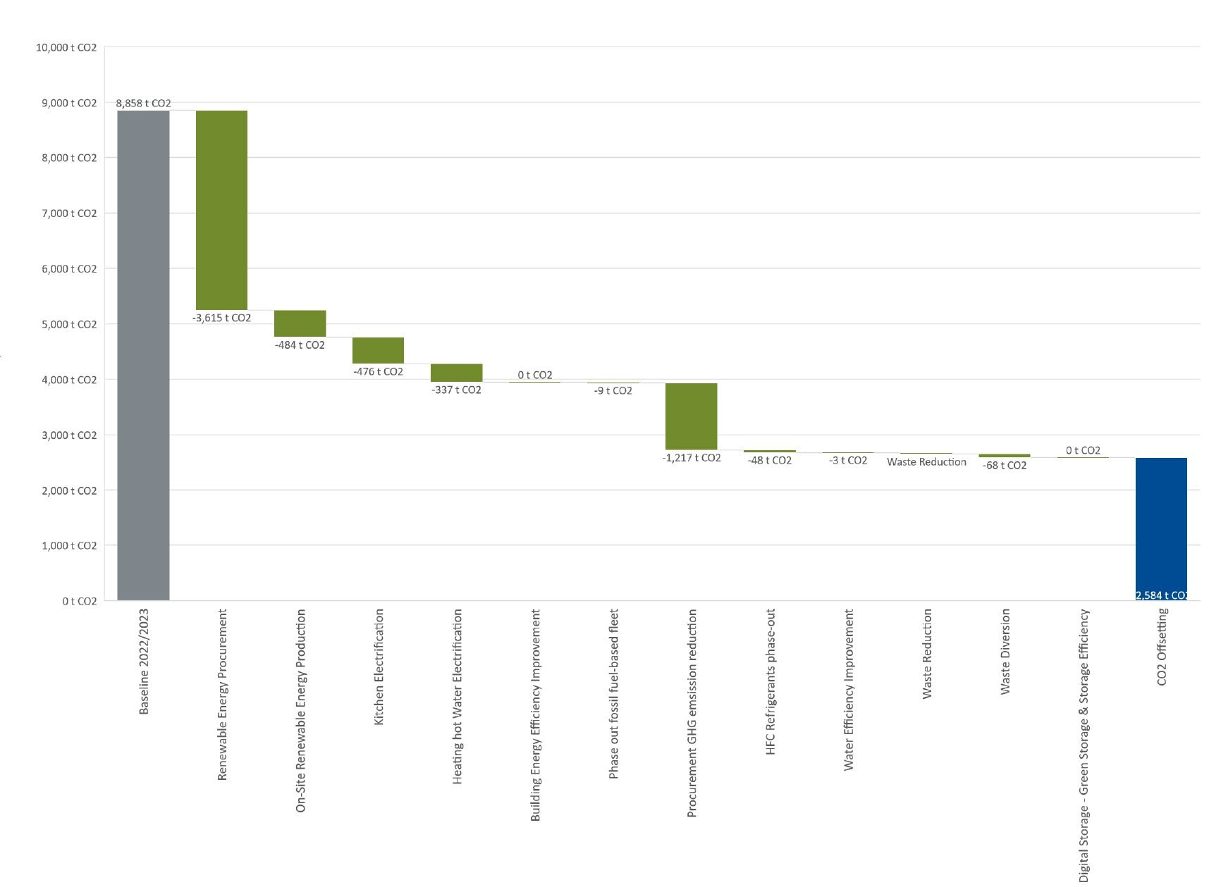

Figure 4: indicative reduction in baseline emissions between 2023 and 2030

# Attachment A – Environmental Action Plan 2024–2030

## NATIONAL LIBRARY OF AUSTRALIA ENVIRONMENTAL ACTION PLAN 2024–2030

|  |  |  |  |  |  |  |  |  |
| --- | --- | --- | --- | --- | --- | --- | --- | --- |
| Category | Target | High level action | Specific Actions | Tasks | Responsible Officer / Project | Target Date | Status (Traffic Light) | Actions taken |
|  | 100% of NLA's electricity  renewable energy sources | Maximise opportunity for onsite renewable. | Complete a solar PV feasibility assessment for Parkes (ACT) building especially focusing on:   * Heritage constraints * Requirements from National Capital Authority * The actual and predicted electrical load profile   Note that 300-550kW may be feasible on this building. The typical daytime electricity demand for NLA is over 600kW so it is unlikely that significant export would be required subject to final confirmation if Authority limits exits. | Investigate and report on options for solar PV installation at the Parkes building. | Director Facilities and Security (FaS) – Environmental Action Plan | 2024 |  | Not yet started. |
| Complete a solar PV feasibility assessment for Hume Repository, especially focusing on the actual and predicted electrical load profile  Potentially 300kW may be feasible on this building, which is far in excess of the typical demand. | Include solar PV as a design option for the northern extension of Hume Repository. Note: Refer Hume Repository Solar PV Report (Rudds, Dec 2012). | Director Collection Storage - Hume Repository Northern Extension project |  | Started - Hume Repository extension design underway. |
| Plan out investment for on-site renewable energy generation projects over a period of 2–5 years, and provide ‘cost assurity’ on level of funding needed. | Cost estimates to be included in Parkes building Solar PV report above.  NLA to decide whether to proceed, and allocate budget to the project. Prepare roll-out plan and program.  Engage contractor to undertake installation | Director Facilities and Security (FaS) – Environmental Action Plan | 2025–2028 |  | Not yet started |
| Establishment of a solar PV system roll-out plan.  Workforce planning to ensure the library has the capacity to deliver the plan. |
| Deliver solar PV system installations |
| **Aust Government Net Zero target: Procure 100% renewable electricity.** | **NOTE: ACT already has 100% renewable electricity already in place.** | **WoAG - Defence led. Monitor.** | Director Facilities and Security (FaS) – Environmental Action Plan | 2023–2030 |  | Completed |
| **Whole-of-Australian-Government (WOAG) electricity procurements begin. Entities must procure electricity through these arrangements when in place in their jurisdiction.** | **Monitor.**  **Implement when existing contract runs out.** | 2024 |  | Not yet started |
| **WOAG mandatory requirement: 80% of the Commonwealth’s electricity consumption, that is generated off-site and purchased by entities, must be renewable.** | **Monitor.**  **Implement when existing contract runs out.** | 2028 |  | Not yet started |
| **WOAG mandatory requirement: 100% of Commonwealth electricity is renewable.** | **Monitor** | 2030 |  | Not yet started |
| Plan to upgrade the capacity of the National Library to be able to support renewable energy powered electricity grid. | Review grid-supportive building services strategies, including demand management, energy storage, and other relevant strategies. Identify the level of grid support possible by a facility like the NLA in the context of transitioning to a renewable energy grid.  (Frequency: Every 5 years) | Investigate options for Parkes (ACT) building and Hume Repository.  Parkes (ACT) building MSB Upgrade project will include additional capacity in the Main Switchboard to allow for future feed-in of renewable energy powered from onsite sources. | Director Facilities and Security (FaS) – Environmental Action Plan | 2024 |  | Started |
| Complete targeted feasibilty studies for suitable grid-supportive building service strategies | Undertake | 2025–2026 |  | Not yet started |
| Roll-out of the shortlisted grid-supportive building services initiatives | Implement | 2027 |  | Not yet started |
| Buildings | 10% improvement in EUI (kWh per m2) by 2027 | Progressively implement work to improve the energy efficiency of the Parkes (ACT) building | Retrofit insulation into building fabric on the envelope of the building. 20% of all spaces complete | Research options for building insulation, focusing on internal insulation because external treatment on the travertine and marble panels is not acceptable due to heritage values. Insulated ceiling tile and adding insulation to interior walls should be explored. Insulating paint could also be explored.  ACM Remediation and Roof Replacement project included installation of insulation in the ceiling cavities above Level 4 and below the new roof sheets. | Director FaS - EAP project  Roof Refurbishment project (completed) | 2025–2026 |  | Internal insulation options investigation not yet started.  Roof works completed (including installation of new insulation) in 2023. |
| Retrofit insulation into building fabric on the envelope of the building. 40% of all spaces complete | Engage contractor to undertake works, or deliver via inhouse maintenance contractor. | Director FaS; Director Capital Works | 2025–2029 |  | Not yet started |
| Retrofit insulation into building fabric on the envelope of the building. 60% of all spaces complete |  | Not yet started |
| Retrofit insulation into building fabric on the envelope of the building. 80-100% of all spaces complete |  | Not yet started |
| Retrofit windows with insulated glazing units (IGUs) to the envelope of the building. 20% of all spaces complete | Replace existing glass and blinds on Lakeside Façade (Levels 1-4) | Director Capital Works: Windows Refurbishment project (current) | 2024 |  | Started in 2023 |
| Retrofit windows with insulated glazing units (IGUs) to the envelope of the building. 40% of all spaces complete | Replace existing glass and blinds on and Commonwealth Ave Bridge Façade and Treasury Façade (Levels 1-4) | 2024 |  | Started |
| Retrofit windows with insulated glazing units (IGUs) to the envelope of the building. 60% of all spaces complete | Replace existing glass and blinds on Ground floor | 2025 |  | Not yet started |
| Retrofit windows with insulated glazing units (IGUs) to the envelope of the building. 80% of all spaces complete. | Replace existing glass and blinds on front entry (Questacon) Façade (ground to L4). | 2025–2026 |  | Not yet started |
| Retrofit windows with insulated glazing units (IGUs) to the envelope of the building. 100% of all spaces complete | Replace existing glass and blinds around courtyards on LG1 and LG2, where appropriate. | Director FaS | 2025–2029 |  | Not yet started |
| Replace all fluorescent lighting with energy efficient LED type lighting, with energy efficient lighting layout. 60% of all spaces complete | Ongoing | Director FaS | 2025 |  | Started in 2022 |
| Replace all fluorescent lighting with energy efficient LED type lighting, with energy efficient lighting layout. 80% of all spaces complete | Ongoing | 2028 |  | Not yet started |
| Replace all fluorescent lighting with energy efficient LED type lighting, with energy efficient lighting layout. 100% of all spaces complete | Ongoing | 2030 |  | Not yet started |
| Improve energy efficiency of the Hume Repository building | Retrofit insulation into building fabric on the envelope of the building.  Replace all fluorescent lighting with energy efficient LED type lighting, with energy efficient lighting layout. | Review insulation and lighting for Repositor building. Carry out work as required.  Ensure design for northern extension includes all relevant sustainability measures, including insulation and lighting. | Director FaS.  Director Collection Storage: Hume Repository, northern extension project (current) | 2024 |  | Started - lighting upgrade programmed via SAMP WP1.  Hume Repository northern extension design underway. |
| Identify other opportunities to reduce energy consumption, through an energy audit program | Create a framework to undertake energy audits (a Type-2, as per AS3598) for Parkes (ACT) building and Hume Repository at a minimum 5 year frequency | Install Smart Meters on equipment. Develop framework for audits. | Director FaS | 2024 |  | Started - new switchboards have been installed. |
| Complete Energy audits for Parkes building and Hume Repository (Frequency: Every 5 years) | Deliver energy audits | 2025 |  | Not yet started |
| Plan out investment in energy efficiency upgrades for the period 2025–2029, and provide ‘cost assurity’ on level of funding needed. | Develop upgrade program with cost estimates | 2025 |  | Not yet started |
| Establishment of an energy efficiency initiative roll-out plan.  Workforce planning to ensure the Library has the capacity to deliver the plan. | Develop plan, using program above. Initiatives could include year-round blind closure at night by staff (not just for the annual Earth Day and during Enlighten). | 2025 |  | Not yet started |
| Deliver Energy Efficiency Upgrades | Manage the program of deliverables | Director FaS | 2025–2029 |  | Not yet started |
| **Aust Government Net Zero target: Lease and own efficient buildings** | **WOAG mandatory requirement: Where a lease is entered into for four or more years over an office space of 1000 square metres or more of net lettable area, the office space and the building in which it is located must have and maintain 5.5 star or higher base building and tenancy NABERS energy ratings.** | **Ensure these requirements are met when the Library contemplates entering leases for any offsite accommodation.** | Director FaS | 2025 onwards |  | Not yet started |
| **WOAG mandatory requirement: Where a contract is entered by or for the Commonwealth for the purchase or construction of office space with a value greater than $15 million, the office space must have and maintain a 6 star NABERS energy rating and GBCA 4 star Green Star rating (minimum) which includes complying with the Climate Positive pathway.** | **Ensure these requirements are met if the Library contemplates this action.** | 2026 onwards |  | Not yet started |
| Continuously review temperature and humidity requirements for each storage area, to identify opportunities to reduce HVAC energy. | Review each collection to determine adequate temperature and humidity boundaries and identify passive solutions to accommodate a wider temperature and humidity band.  (Frequency: Annually) | Collection Care set parameters for each stack and broaden temperature ranges where possible to reduce energy usage. | Director Collection Care | 2024–2029 |  | Started |
| Update HVAC controls to suit wider control bands (Frequency: Annually) | Performance of stacks is monitored to ensure Collection Care temperature and humidity parameters are being met. BMS controls are re-set to reduce energy usage where possible. | Director FaS | 2024–2029 |  | Started |
| Buildings (Electrification) | Eliminate any on-site fossil fuel use by **2027** | Electrification of existing on-site gas powered equipment in kitchens. | Populate an equipment schedule of kitchen gas-powered equipment and their potential electric replacements. | Replace gas-powered kitchen equipment in Bookplate | Director FaS | 2024 |  | **Completed - May 2024** |
| Assess the order of costs for the supply and install of the alternative electric solutions |
| Roll-out of the equipment replacement |
| Electrification of existing gas powered building services equipment. | Populate an equipment schedule of all gas-powered building services equipment and their potential electric replacement. | Develop schedule to replace 3 gas fired boilers and change over to electric heating.  Engage consultant to be scope boiler replacements | Director FaS | 2026–2027 |  | Not yet started |
| Review key opportunities and constraints relating of each potential concept for HVAC equipment electrification | Review BBS2 equipment schedules to identify opportunities to choose different equipment models during the design phase.  Review the HVAC equipment installed during HVAC Stages 1 - 3 to determine whether any of the equipment needs to be changed over in the next 5-7 years. | Director Capital Works: BBS2 Project (current project).  Director FaS. | 2024 |  | Not yet started |
| Establish a timeframe and plan for electrification | Develop electrification plan | Director FaS | 2024 |  | Started - consultant engaged |
| Deliver on electrification works | Manage works | Director FaS | 2025–2030 |  | Not yet started |
| Alternative energy source for Diesel backup for Fire Systems at Hume Repository | Investigate alternative energy options for diesel at Hume. | Engage consultant to look at alternatives and scope for the Library | Director FaS | 2026–2027 |  | Not yet started |
| Alternative energy source for the diesel backup for SCC at NLA | investigate alternative energy options for diesel at Parkes (ACT) building | Engage consultant to look at alternatives and scope for the Library | Director FaS | 2026–2027 |  | Not yet started |
| **Aust Government Net Zero target: Lease and purchase all-electric buildings.** | **WOAG mandatory requirement: Where a lease is to be entered into for office space, entities should prefer all-electric buildings, particularly if the Commonwealth is directly responsible for base building services costs.** | **Ensure these requirements are considered when the Library contemplates entering leases for any offsite accommodation.** | Director FaS | 2024 onwards |  | Completed - leased office space at 6 National Cct Barton is all-electric |
| **WOAG mandatory requirement: Where a contract is entered for the purchase or construction of office space for the Commonwealth, the office space must be all-electric. This includes building heating, cooling and water heating but excludes backup generation, subject to the 2026-27 review.** | **Implement requirement if purchasing or constructing office space** | Director FaS | 2026 onwards |  | Not yet started |
| **WOAG mandatory requirement: Entities should only lease or own office space that is all-electric.** | **Implement** | Director FaS | 2040 |  | Not yet started |
| ICT | 50% reduction in annual CO2 emission per terabyte of stored data.  20% reduction in EUI for on- site digital storage by 2028.  Be in top 25% of peers for energy use intensity (EUI) using a relevant benchmark, such as NABERS | Benchmark current on-site and off-site digital storage. | Install sufficient metering to measure the electricity and cooling use of on-site digital storage. | Facilities to install meters on IT Server Room power supplies and ensure meters are connected to BMS and data is captured. | Director FaS | 2024 |  | **Completed** |
| Benchmark existing on-site digital storage energy use, both absolute energy consumption and energy consumption per functional unit (appropriate functional unit to be identified).  Benchmark against the NABERS Energy for Data Centres for a comparison against industry peers. | Facilities to develop benchmark for on-site digital storage use in consultation with Digital branch.  Digital branch to benchmark against NABERS Energy for Data Centres. | Director FaS  CIO | 2024 |  | Not yet started |
| Benchmark existing off-site purchased digital storage energy use and emissions. Energy and emissions to be benchmarked as absolute figures, and per functional unit (appropriate functional unit to be identified). | Digital branch to develop benchmark | CIO | 2024 |  | Not yet started |
| Benchmark emissions profile of existing cloud software subscriptions, where the primary function of the subscription is not storage (i.e. A cloud based editing software that may have digital storage as part of the service, but is not the primary function). Emissions to come from supplier benchmarked data. | Digital branch to develop benchmark | CIO | 2024 |  | Not yet started |
| Optimisation of the on-site and off-site digital storage strategy. | Review and recommend improvements to the equipment selection and operation strategies of on-site digital storage to improve EUI by 20% by 2028 and be in the top 25% of peers for EUI. | Digital branch to conduct review and include recommendations in the Digital Strategy | CIO | 2025 |  | Not yet started |
| Review options for off-site storage to lower emissions, including:   * revising functional brief to allow for lower energy use storage, * alternate suppliers with lower energy consumption and/or greater renewable energy supply.   Investigate potential for optional extras from suppliers, including carbon neutral services, tape storage etc. | Digital branch to implement | CIO | 2025 |  | Not yet started |
| Review options for cloud software subscriptions to lower emissions. Investigate potential for optional extras from suppliers, including carbon neutral services. | Digital branch to implement | CIO | 2025 |  | Not yet started |
| **Aust Government Net Zero target: data centres** | **New data centre facilities that are sourced outside the whole-of-Australian-Government panel**  **arrangement, whether owned or leased by the Commonwealth, are required to achieve and maintain 5 stars NABERS Energy for Data Centres or equivalent environmental rating such as a Power Usage Effectiveness of 1.4 or less.** | **Monitor and implement where necessary** | CIO | 2025 |  | Not yet started |
| Buildings (EV Charging) | Install charging to support fleet and staff electric vehicle use, in all car parks where more than 10 vehicles are expected to park daily, by 2025. | **Aust Government Net Zero target: Provide electric vehicle charging facilities** | **WOAG mandatory requirement: All office space with allocated parking must have an electric vehicle charging plan where possible.** | **Develop electric vehicle charging plan for offsite accommodation (leased space), Parkes (ACT) building and Hume Repository.** | Director FaS | 2024 |  | Not yet started |
| **WOAG mandatory requirement: Office space with allocated parking should have facilities to support electric vehicle charging where possible, if an entity has electric fleet vehicles on site.** | **Implement charging plan and install electric charging stations as per the plan.** | Director FaS | 2025 |  | Not yet started |
| Existing power outlet facility at Service Yard, Parkes (ACT) building to be increased. | Increased outlets at Facilities for greater expansion of existing outlets | Expected growth of use of electric bikes/scooters so this is to accommodate future requirements. | Investigate options for a viable solution that meet the Libray's commitment | Director FaS | 2025–2029 |  | Not yet started |
| Fleet | Reduce emissions associated with transport of freight and company vehicle use by 50% by 2030. | Review sizing for collections delivery truck | Complete an analysis of the past utilisation of existing diesel truck and predict the future utilisation.  Identify the optimal loading capacity of the truck for the majority of the trips, rather than sizing to accommodate the peak load requirement. Note that third party operators can meet minority of trips requiring a larger loading capacity. | Research options | Director Reader Services | 2025 |  | Not yet started |
| **Aust Government Net Zero target: Overall fleet targets for low emissions vehicles** | **WOAG mandatory requirement: Target of 25% of new passenger vehicle orders to be low emission vehicles, with a preference for zero emission vehicles.** | **Leased corporate car for new leased office space to be hybrid** | Director PMO & Procurement | 2023 |  | **Completed** |
| **WOAG mandatory requirement: Target of 50% of new passenger vehicle orders to be low emission vehicles, with a preference for zero emission vehicles.** | **New hybrid on order as second fleet car for Parkes (ACT) building** | Director PMO & Procurement | 2024 |  | Started |
| **WOAG mandatory requirement: Target of 75% of new passenger vehicle orders to be low emission vehicles, with a preference for zero emission vehicles.** | **Ensure this is met** | Director PMO & Procurement | 2025 |  | Not yet started |
| Procurement | Reduce emissions associated with purchased goods and services, through procurement initiatives and engaging with key suppliers.  Target of 30% reduction in absolute emissions by 2030. | Develop and improve environmentally sustainable procurement processes over time | Identify products or services that have similar emissions profiles or environmental impact profiles, and categorise into groups (on the basis that prescriptive 'minimum environmental requirements' can be written that apply to all products and services in a group). | Suggested groupings – Technical Services, Building and Facility Maintenance, Hardware and Computer Electrical Components, HR, Applications and Subscriptions. | Director PMO & Procurement | 2024 |  | Not yet started |
| Develop technical specifications for each group of products and services as ‘minimum standards’ to achieve, ensuring lower emissions than typical for that product or service. | Liaise with PMO. | Director PMO & Procurement | 2026 |  | Not yet started |
| For products without a specified 'minimum standard', implement more general sustainable procurement policies to identify products, services and suppliers with sustainable attributes. | PMO to reach out to existing Panels for advice on how they will implement environmentally sustainable practices. | Director PMO & Procurement | 2025 |  | Not yet started |
| **Aust Government Net Zero target: include environmental sustainability and climate change in procurement practices** | **Australian Government to develop and publish the Environmentally Sustainable Procurement Policy.** | **PMO to update internal Library documents once this Policy has been published.** | Director PMO & Procurement | 2025 |  | Not yet started |
| **Australian Government to deliver capability uplift for decision-makers to evaluate climate information from suppliers and enhance assessment under the Commonwealth Procurement Rules.** | **PMO to monitor and advise the Library on this once CPRs have been updated.** | Director PMO & Procurement | 2026 |  | Not yet started |
| **Australian Government to develop the scope 3 cost modelled assessment and work with agencies in its development.** | **PMO to monitor and advise on this once Scope 3 assessment has been modelled.** | Director PMO & Procurement | 2025 |  | Not yet started |
| Quantify emissions from suppliers, and increase accuracy over time. | Build on scope 3 cost modelled assessment to quantify 50% of emissions using supplier specific emissions profiles, rather than cost modelled estimates or industry profiles. |  | Director PMO & Procurement | 2029 |  | Not yet started |
| Refrigerants | Reduce and eliminate greenhouse gas emissions from refrigerant leakage and end-of-life disposal. Align with Australian HFC phase- down commitments, by targeting 55% of refrigerant use (by cooling capacity) to be non-HFC in 2030 and 85% non-HFC in 2036. | Review chillers and heat pumps for new ‘drop- in’ replacement refrigerants with low Global Warming Potential (GWP | Create a Refrigerant tracker with refrigerant type, quantities and maintenance information for all HVAC equipment operating with refrigerants | Implement.  Update SAMP and lifecycle cost plan to include recommendations in relevant projects. | Director FaS | 2024–2029 |  | Not yet started |
| Market review of drop-in replacement refrigerants (ongoing activity every 5 years) |
| Replace chillers and heat pumps with lowest possible GWP technology at end of life. | Market review of suitable refrigerants with lowest GWP for chiller and heatpump replacement at end of life (ongoing activity every 5 years) |
| Use information to inform asset life cycle replacement program |
| Review fridges and freezers (and any other refrigerant containing equipment) and identify replacement technologies with low GWP. Include in the scope of any energy audits. | Create a Refrigerant tracker with refrigerant type, quantaties and maintenance information for miscellaneous equipment operating with refrigerants (e.g. fridges) | Implement.  Update SAMP and lifecycle cost plan to include recommendations in relevant projects. | Director FaS | 2024–2029 |  | Not yet started |
| Market review of suitable refrigerants with lowest GWP for miscellaneous equipment to be considered at end of life replacement (ongoing activity every 5 years) |
| Use information to inform asset life cycle replacement program |
| Water | Improve water efficiency of the buildings, and thereby reduce emissions associated with water supply, sewage and hot water heating.  10% water consumption reduction by 2028 | Identify opportunities to reduce water consumption. | Complete a water audit for Parkes (ACT) building and Hume Repository, and benchmark the outcome against the historic performance of the facilities  (Frequency: Annually) | Complete audit | Director FaS | 2024 |  | Not yet started |
| Identify possible initiatives and complete a feasibility assessment | Identify options | Director FaS | 2025 |  | Not yet started |
| Deliver the selected initiatives | Implement approved initiatives | Director FaS  Director Collection Storage: Hume Repository extension project (current project) | 2024–2029 |  | Hume Repository extension - design docs to include rainwater tanks. |
| Review use of rainwater or grey water for mechanical equipment and/or heating and cooling | Investigate options and make recommendations to the Library.  Implement approved option/s when appropriate through major or minor building projects. | Director FaS  Director capital works | 2024 –2029 |  | Not yet started |
| Complete a feasibility assessment for rainwater use for landscape irrigation or for toilets | Undertake feasbility assessment and recommend initiatives | Director FaS | 2024 |  | Not yet started |
| Deliver the rainwater use initiatives | Implement approved initiatives | Director FaS | 2025 |  | Not yet started |
| Waste | Reduce emissions associated with waste disposal.  Reduce waste generation rates in building works and operation by 20% by 2030.  Target diversion from landfill rates of 80% for for building works and operation. | Reduce waste volumes through sustainable procurement policies | Refer to sustainable procurement actions. | Monitor. Liaise with Director, PMO. | Director PMO & Procurement | N/A |  | Not yet started |
| Implement circular economy initiatives to reuse products and materials that would otherwise be considered at end of life and disposed of. | Develop a 'Materials Recycling and Reuse Plan' template for use on projects, to track kg per m2 waste generation rates on building works project, and percentage of waste diverted from landfill. | Create an inventory of materials and equipment that are being removed during building or other projects, and identify opportunities for reuse.  Identify design strategies that minimise the need for materials on the project. Create the template.  Revise project documentation to incorporate approved strategies to minimise waste during works.  Train project managers across the Library in use of the new project documentation. Re-use of Heritage stored materials  PMO to update existing templates to consider environmental impacts when planning project and procurement activities. | Director FaS  Director PMO & Procurement | 2024 |  | Not yet started |
| Implement Materials Recycling and Reuse Plan on pilot project. | Choose a pilot project and train the project manager to use the template.  PMO will ensure the Pilot Project has included the new template as part of project initiation. | Director PMO & Procurement | 2024 |  | Not yet started |
| Include Materials Recycling and Reuse Plan as part of standard building works program. | Collate results from completed projects and review strategies. Update as necessary. | Director FaS; Director Capital Works | 2025 |  | Not yet started |
| Identify opportunities for recycling and reuse of materials across the Library.  Develop a process for recycling and/or reuse of materials from Library activities and services | Consult with all branches re purchase and use materials and/or equipment for projects, such as Digital Branch for ICT equipment, Engagement Branch for exhibitions materials and bookshop materials, Collection Branch for archival boxes, paper etc.  Develop process for recycling and/or reuse of materials and equipment across the Library. | Director PMO & Procurement Director FaS | 2026 |  | Not yet started |
| Reduce amount of waste to landfill through separation and recycling initiatives. | Commission visual waste audit for operational facilities, identifying opportunities to improve diversion from landfill rates. | Conduct audit. | Director FaS | 2025 |  | Not yet started |
| Track annual waste generation and diversion rates, and put in place triggers for investigation of opportunities. Typically early intervention would be internal review, followed by an audit if underperformance is sustained. | Review waste management figures for Parkes, Hume Repository and Annexe. Investigate excessive waste disposal where appropriate. | Director FaS | 2025 |  | Not yet started |
| Embodied Energy – Capital Works | Reduce emissions embodied  in the products and materials supplied through the capital works program. | Develop and improve material purchasing processes over time. | Identify products or services that have similar emissions profiles or environmental impact profiles, and categorise into groups (on the basis that prescriptive 'minimum environmental requirements' can be written that apply to all products and services in a group). | Review and categorise. | Director Capital Works | 2025 |  | Not yet started |
| Develop technical specifications for each major type of project delivered as capital works or other major building works programs, outlining requirements to achieve. | Progress. | Director Capital Works | 2025 onwards |  | Not yet started |
| NLA Business Operation areas | Reduce usage of non- environmental materials | Phase out use of non-environmental materials in collections | Carry out re-housing and re-packaging audit | Project plan approved | Director Collection Care | 2024–25 |  | Started - being drafted |
| Implement recommendations from audit | As appropriate | Director Collection Care | 2026–2030 |  | Not yet started |
| Review financial investments against Scope 3 requirements | Ensure investments meet Scope 3 requirements | Establish the Scope 3 requirements in relation to investments. | Identify Scope 3 requirements in relation to investments. Recommend appropriate changes to the Executive and Council | CFO | 2024 |  | Not yet started |
| Monitor changes to Scope 3 requirements and implement as appropriate | Implement changes to investments as required | CFO | 2025–2030 |  | Not yet started |
| People, Culture and Capability | Aust Government target: Chief Sustainability Officer role in the organisation, and capability uplift support | Entities are encouraged to identify a Chief Sustainability Officer role within their organisation at an appropriate level and delegation to champion the Net Zero in Government Operations Strategy and related initiatives that support climate action in government operations. | Director FaS as Chief Sustainability Officer, and identified in key Library documents, including the Corporate Plan, Annual Report and this Action Plan. | Director FaS | 2024 |  | Not yet started |
| The Department of Finance will support capability uplift across entities, including through advice, guidance, tools, case studies and training programs via the APS Academy. The Climate Action in Government Operations website and GovTeams community will iunclude general information and guidance. | The Chief Sustainability Officer and other nominated Library staff with environmental responsibilities will participate in the activities and forums offered by Dept of Finance. | Chief Sustainability Officer and others as required | 2024–2030 |  | Not yet started |

National Library of Australia

Visit the [National Library of Australia website](http://www.nla.gov.au/)

© Commonwealth of Australia 2025

Logo

With the exception of the National Library of Australia logo and all photos and graphics, this report is licensed under a Creative Commons Attribution 4.0 International Licence. Licence is a standard form license agreement that allows you to copy, distribute, transmit and adapt this publication provided that you attribute the work. The Commonwealth’s preference is that you attribute this publication (and any material sourced from it) using the following wording:

Source: Licensed from the Commonwealth of Australia under a Creative Commons Attribution 4.0 International Licence.

To view a copy of this licence visit the [Creative Commons website](https://creativecommons.org/licenses/by/4.0/).

Disclaimer:

The Commonwealth of Australia does not necessarily endorse the content of this publication.