National Library of Australia

APS Net Zero by 2030

Emissions Reduction Plan 2024

Contents
Acknowledgement of Country 2
Accountable Authority Sign off 4
Emissions Reduction Plan 5
Purpose 5
Net zero greenhouse gas emissions 5
Governance and reporting 5
The National Library’s Operational Context 5
Property 6
Parkes Building 6
Hume Repository 7
APS Net Zero 7
Baseline emissions 9
Engagement 9
Emissions reduction targets 9
Priorities and actions 9
Appendix 1 – Environmental Action Plan 10

Version History

Date | Reviewed/ Actioned By | Version | Action
July 2024 | Director, Building Futures, Property and Sustainability | 1 | Revised draft Plan
July 2024 | Assistant Director-General, Property and Sustainability | 2 | Reviewed draft final Plan
August 2024 | Executive Review | 2 | Reviewed final draft Plan
August 2024 | Chair, National Library of Australia Council | 2 | Sign final Plan

Acknowledgement of Country

The National Library of Australia acknowledges Australia’s First Nations Peoples – the First Australians – as the Traditional Owners and Custodians of this land and gives respect to the Elders – past and present – and through them to all Australian Aboriginal and Torres Strait Islander people.

Accountable Authority Sign off

The Australian Government released the Net Zero in Government Operations Strategy in November 2023, setting out the overall approach and action required by Commonwealth entities to achieve the APS Net Zero 2030 target.
The Net Zero in Government Operations Strategy represents a strong commitment by the Australian Government to lead by example on emissions reduction and contribute to the decarbonisation of Australia’s economy.
The National Library is committed to the achievement of the Government’s APS Net Zero 2030 target. The National Library is following the APS Net Zero 2030 target in full, as per the Net Zero in Government Operations Strategy.
This Emissions Reduction Plan describes the priorities and actions the National Library is taking to reduce our operational emissions and contribute to the APS Net Zero 2030 target.

Emissions Reduction Plan

Purpose

The National Library is responsible for managing and implementing emissions reduction initiatives set by the Australian Government’s Net Zero in Government Operations Strategy (the Strategy) developed by Department of Finance. The Strategy sets out the Australian Government’s approach to achieving net zero greenhouse gas emissions from its operations by 2030 and the reinstatement of public emissions reporting.
The goal of this Emissions Reduction Plan is to provide a pathway for the National Library to contribute to the achievement of the APS Net Zero 2030 target through emissions reduction activities. This plan encompasses existing and new priorities and actions within the National Library to reduce emissions.
This Emissions Reduction Plan has been completed in accordance with the Strategy, associated guidance and reporting standards for annual emissions reporting.

Net zero greenhouse gas emissions

APS Net Zero 2030 is the target set by the Australian Government to achieve net zero greenhouse gas emissions from government operations by the year 2030. It includes scope 1 and scope 2 emissions from activities in Australia and its territories, as described in the Strategy.
The APS Net Zero 2030 target applies at the aggregate level to non-corporate Commonwealth entities and generally covers the entirety of the entity’s organisation. From an organisational perspective, this means minimising the greenhouse gas emissions that are within our control.

Governance and reporting

Progress against actions identified within this Emissions Reduction Plan, and any additional measures adopted, will be included in our annual reports. This, combined with annual emissions reporting, will be used as a measure of the National Library’s progress towards reducing its emissions.
As part of the Net Zero in Government Operations Annual Progress Report, the Department of Finance will aggregate these measures to provide whole-of-Australian Government emissions reporting.

The National Library’s Operational Context

The National Library is one of several agencies within the Department of Infrastructure, Transport, Regional Development, Communications and Arts portfolio.
The National Library’s role, as defined by the National Library Act 1960, is to ensure that documentary resources of national significance relating to Australia and the Australian people, as well as significant non- Australian library materials, are collected, preserved and made accessible either through the National Library itself or through collaborative arrangements with other libraries and information providers.
The National Library of Australia is a world-leading and respected custodian of Australia’s published, written, oral, visual and digital heritage. We ensure Australian culture and knowledge is sustained for all Australian people, now and in the future.
The National Library’s vision is to connect all Australians with national collections, enriching conversations about who we are and our place in the world. We hold a massive and incredibly diverse collection exceeding

10 million physical items, currently occupying 273 shelf kilometres (LKM). Physical items include those made from paper, metal, film and sound recordings, paintings, fabric, ceramic and furniture.
Under the National Library Act 1960, the National Library has a legal obligation to ensure that documentary resources of national significance relating to Australia and the Australian people, as well as significant non- Australian library materials, are collected, preserved and made accessible.
The National Library also has obligations under the Copyright Act 1968 to acquire legal deposit copies of all works published in Australia, it receives donations and is offered opportunities to acquire items. On average, the physical collection grows by 2 - 2.5 LKM per year.
The National Collection also includes digital material, currently comprising 2.96 petabytes. In 2023-24, digital items made up 61% of the material collected.

Property
The National Library owns and manages two buildings in Canberra:
- The National Library building at Parkes Place, Parkes, ACT.
- The Repository, corner of Tralee Street and Monaro Highway, Hume, ACT - offsite collection storage facility.
The National Library also leases the following spaces:
- Hume Annexe, 64 Shepard St, Hume, ACT - offsite collection storage facility.
- National Archives of Australia, Mitchell, ACT – a portion of the building is leased for offsite collection storage until June 2026.
- 6 National Circuit, Barton, ACT – 3-year offsite office accommodation lease during ongoing building works at the main building.

Parkes Building
The Parkes (ACT) building is entered in the Commonwealth Heritage List [ID. No. 105470] under the heritage provisions of the Environment Protection and Biodiversity Conservation Act 1999 (EPBC Act), for its historic heritage values.
The Parkes (ACT) building currently incorporates the following uses:
- Specialised collection storage – the building houses the most significant and high usage collection material. Items are stored in a variety of ways, on open shelving, in cabinets and compactus. Storage spaces are known as ‘stacks’ and occur throughout the building on every floor. Each stack has different environmental conditions relating to the requirements of the items housed in it (ie. the Lakeside stack on Lower Ground Floor 2 (LG2) is passive, whereas the Maps stack on Lower Ground Floor 1 (LG1) is climate controlled).
- Public spaces – events and exhibition spaces, and collaboration spaces.
- Retail spaces - bookshop, café.
- Reading room spaces – main reading room accessible to all the community, and the special collections reading room available to researchers.
- Staff workspaces – general office fit outs; photographic and digitisation studios; preservation lab; exhibition workshop; kitchenettes on each floor; Oral History recording studio (sound proofed booths with specialised recording equipment).

- Back of house – commercial kitchen for café; 5 general lifts and one book lift; plant and utility service areas; digital, IT server room, and comms network spaces; non-collection storage spaces; quarantine rooms; loading dock; cleaners’ office, maintenance contractor's office/workshop; security control centre; cool/cold store (for collections).
The occupied area of the building is 43,860m2, broken up by function as follows:

Function | Area (m2) | Percentage of building (%)
Amenities | 358 | 1
Circulation | 3,778 | 9
Core facilities | 2,441 | 6
Exhibition | 694 | 2
Workspace | 9,088 | 21
Public | 4,681 | 11
Retail | 524 | 1
Services/plant | 2,725 | 6
Special function | 859 | 2
Collection storage | 16,680 | 38
Non-collection storage | 2,032 | 5

The primary use of the main building is for storing collections which are high use, highly valuable and/or significant, and generally require climate-controlled conditions (either temperature, or temperature and humidity). It also provides staff workspaces and access to the public.

Hume Repository
The Hume Repository was constructed in 2004-2005, opening in August 2005. The primary use of the facility is for storage of collections. It also has a small office, kitchen, toilets, plantroom, utilities area, and loading dock in addition to the large storage area. The total area is 3,740m2.
An extension of the Hume Repository will be built in 2024 – 2025. The design of the extension module includes opportunities for energy savings and other measures (ie. provision for installation of solar panels) which will assist the National Library to meet Net Zero targets. The extension area will be 1,005m2.
The Repository, and the Hume Annexe, store collections which are medium or low use, and do not generally require climate-controlled conditions. Although the Repository has a Heating Ventilation and Air Conditioning (HVAC) system, it was turned off in 2012 during a 12-month trial looking at passive conditions for collections. It has not been turned back on.

APS Net Zero
The National Library has already commenced its net zero emissions pathway in line with the direction set in the Strategy.
The National Library has been reviewing and managing its climate controls for collections since 2001, when a review of international standards and practices resulted in the development of the first Environmental Management Plan. This plan saw us tighten our climate control parameters at the time in line with what had

become the unofficial standard of 20⁰C ± 2⁰C and relative humidity (RH) of 50% ± 5% for storing paper- based collections.
In 2012 the National Library moved towards passive climate control by implementing the 12-month trial at the Repository. In that period, conditions in the building were generally maintained at averages of around 16- 20⁰C and 48% RH, even during a month which saw average outside temperatures of over 30⁰C, and one week of temperatures over 35⁰C. There were energy savings of 345,237 kilowatt hours (kWh) or $40,000 over the 12-month period. One of the key findings was that paper collections buffer conditions and improve building thermal mass.
Passive controls are still maintained at the Annexe and Repository, and we continue to review and manage climate controls in these two buildings and in the main building.
In 2012 the National Library also commissioned a feasibility report on installation of solar photovoltaic (PV) panels at the Repository. Although deemed feasible, this was not progressed. Re-visiting solar PV for the Repository and the main building are activities in the Environmental Action Plan.
Other actions completed or in progress include:
- Purchasing renewable electricity through the ACT Government.
- Engaging a consultant to assist in scoping requirements for a compliant response to APS Net Zero and to update our action plan, baseline our carbon footprint, design an actionable program to meet APS Net Zero requirements (the environmental action plan), and enhance the environmental management system.
- Continuing to progress two major building infrastructure projects aimed at improving building performance and energy efficiency in the Parkes (ACT) building:
  - Heating Ventilation and Air Conditioning (HVAC) Upgrade Phase 1 stages 1 -3: replace and refurbish the most pressing end of life HVAC plant and equipment.
  - Heritage Windows Replacement Project: replacement and refurbishment of aging heritage windows to remediate loss of conditions and leaks on all building facades.
- Completing the copper roof replacement project, which gave us an opportunity to install insulation in the ceiling cavity and roof space above Level 4 in the Parkes (ACT) building and add two additional layers below the copper roof sheets – a waterproof membrane and a ply sub-structure – to further improve the thermal efficiency of the building.
- An ongoing program of changing over old fluorescent globes to LEDs in the buildings.
The nature of our operation means that collections will continue to grow, physically and digitally. Our online presence will continue to increase through outreach programs as well as providing access to digital collections through our online catalogue, Trove. There is no current baseline emissions data for our digital storage but, through the installation of Smart Meters on the new Computer Server Room in early 2024, we will start to capture and report this data.
There is also no baseline data at this time for digital storage, legal deposit (which is now predominantly digital), or for the National Collection, but this will be a focus in the next 2 years, allowing us to add to the data provided in our annual reports over time.
The National Library expects there will be changes to our physical buildings over the next 10 years, through projects coming out of the Building and Collection Storage Master Plan or the Strategic Asset Management Plan, and these will provide opportunities to address environmental sustainability by incorporating emissions reduction measures. The challenge of reducing emissions in a heritage building is not underestimated.

There will also be changes to the way we work, arising from the COVID-19 pandemic and Australian Government workplace policies, which will affect our emissions and for which the data will need to be captured. Digital activity will increase in the cyber security and Artificial Intelligence spaces.
The challenge for the National Library will be in offsetting the growth of collections with their complexity of storage requirements, along with digital storage and performance against the requirement to reduce emissions to zero by 2030.

Baseline emissions
Baseline emissions are a record of greenhouse gases that have been produced in the past and were produced prior to the introduction of any strategies to reduce emissions. The baseline emissions from financial year 2022-23 are the reference point against which emissions reduction actions can be measured.
The baseline emissions for this plan focus on scope 1 and scope 2 emissions, consistent with the APS Net Zero 2030 target. Electricity-related emissions were calculated using the location-based method. The complete 2022-23 greenhouse gas emissions inventory tables for the National Library are presented in our 2022-23 annual report. It should be noted that the scope 1 emissions for natural gas in the Annual Report were incorrect, and therefore the total scope 1 emissions figure is also incorrect. Corrections are included in the 2023/24 Annual Report.

Baseline year | Financial year 2022-23
Scope 1 emissions | 392.562 tCO2e
Scope 2 emissions | 3,340.868 tCO2e
Total emissions | 3,733.43 tCO2e
It is noted, however, that requirements for the 2023 – 24 Greenhouse Gas Emissions Inventory cover scope 1, 2 and 3 emissions. The Emissions Inventory will be included in the National Library’s Annual Report.

Engagement
In the development of this plan the National Library has been working with the Department of Finance:
- Climate Action In Government Operations – to ensure that this plan aligns with the Net Zero in Government Operations Strategy and the Commonwealth Climate Disclosure requirements.
- Fleet Team – to discuss options associated with low emissions vehicles.

Emissions reduction targets
The National Library is following the APS Net Zero 2030 target in full, as per the Net Zero in Government Operations Strategy. The target covers the entirety of our entity’s operations within Australia and its territories for scope 1 and scope 2 emissions, as described in the Strategy.

Priorities and actions
For the National Library to contribute to the achievement of the APS Net Zero 2030 target, targeted action on existing emissions reduction measures and the introduction of further or new measures is required. The National Library’s priorities and actions to meet Net Zero are set out in Appendix 1 – Environmental Action Plan 2024 - 2030.

Appendix 1 – Environmental Action Plan 2024 – 2030

BACKGROUND
The environmental action plan
The Library’s Environmental Management System (EMS) was developed in 2010 and comprises a suite of templates and guidance documents for management, monitoring and auditing of environmental management practices, as well as reporting.
The existing Environmental Action Plan (Plan) was developed in 2014, and a number of activities have been delivered:
- a three-bin system for grading kitchen waste.
- added mobile phone recycling and mixed light recycling.
- replaced call slip printers with more efficient equipment.
- reduced the fleet to 1 vehicle.
- improved the facilities available for cyclists.
- continued to maintain passive conditions for offsite storage.
- implemented an ongoing lighting upgrade program, to reduce energy usage and improve efficiency.

Since 2014 several environmental policies and measures have been introduced by the Australian Government, most recently the APS Net Zero by 2030 Policy.
APS Net Zero Emissions by 2030 Policy
The APS Net Zero Emissions by 2030 Policy (Policy) has two parts. The Australian Public Service (APS) must:
- reduce its greenhouse gas emissions to net zero by 2030; and
- transparently report on its emissions from the latter half of 2023.


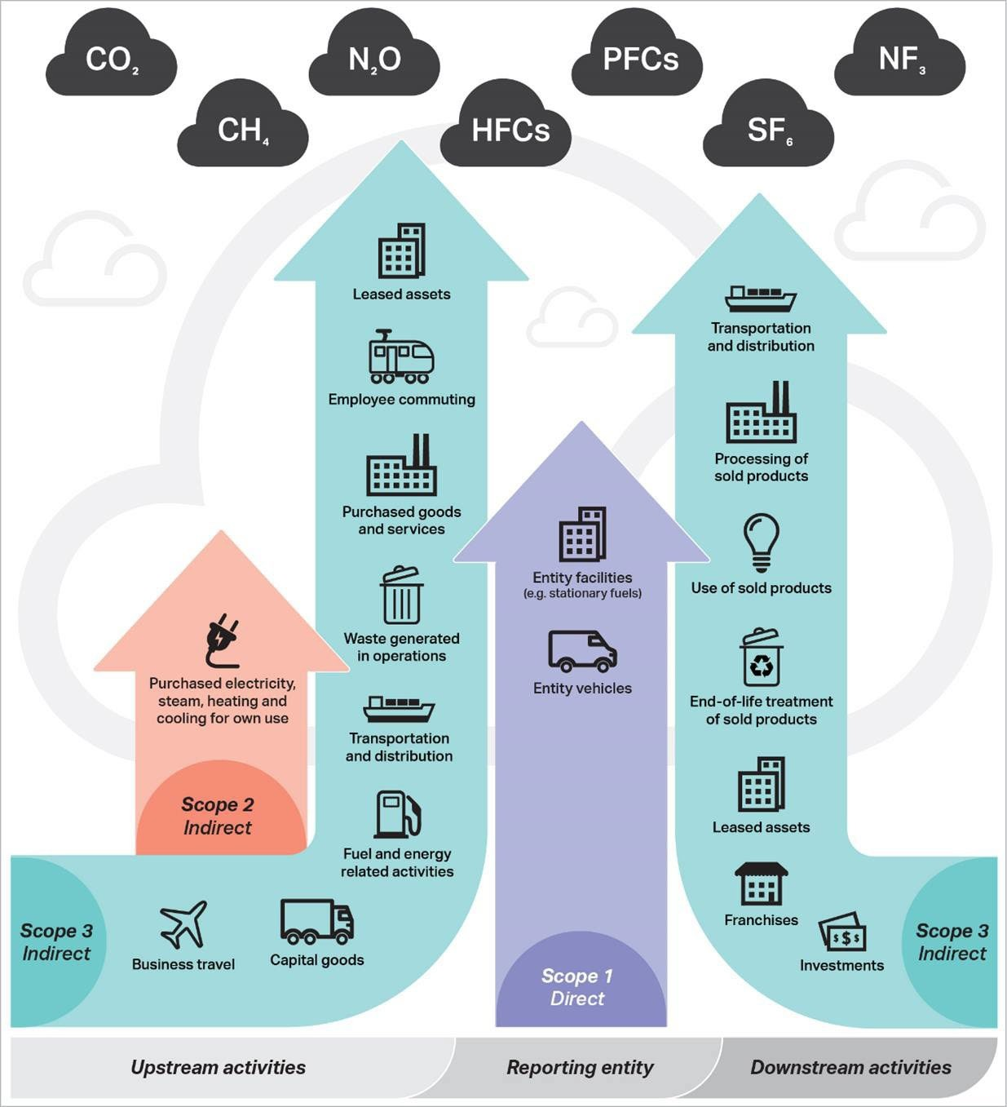
The Policy includes all Scope 1, 2 and 3 emissions attributed to the APS (see Figure 1).
Figure 1: scope 1, 2 and 3 emission categories

The Net Zero in Government Operations Strategy (Strategy) describes the approach for implementing the Australian Government’s commitment to achieve net zero in government operations by 2030. The Strategy was launched on 28 November 2023. Under the Strategy, the APS Net Zero 2030 target only covers scope 1 and 2 emissions. Decisions on scope 3 will be made in the future.
However, requirements for the 2023 – 24 Greenhouse Gas Emissions Inventory cover scope 1, 2 and 3 emissions. The Emissions Inventory will be included in the National Library’s Annual Report. To report on scope 3 emissions, the National Library will have to collect this baseline data.

Baseline Emissions
Baseline emissions are a record of greenhouse gases that have been produced in the past and were produced prior to the introduction of any strategies to reduce emissions, and the baseline emissions for this plan focus on scope 1 and scope 2 emissions, consistent with the APS Net Zero 2030 target. Electricity- related emissions were calculated using the location-based method. The complete 2022-23 greenhouse gas emissions inventory tables for the National Library are presented in our 2022-23 annual report.
In 2023–24 the National Library commissioned Lucid Consulting (Lucid) to update the EMS, establish a carbon footprint baseline, and design an actionable program to meet APS Net Zero requirements to assist the National Library to meet the Australian Government’s environmental commitments.
An assessment of the National Library’s annual emissions was undertaken by Lucid in 2023, following consultation with key Library stakeholders including Facilities, Capital Works, Collection Care, Technology Operations and Finance teams using the following data:
- Consumption data from utilities, including energy and water.
- Waste disposal and diversion from landfill reports.
- Audit of large refrigerant-containing equipment.
- Staff travel records.
- Spend data by financial account code.

Figure 2 shows existing emissions breakdown per category per scope in tonnes of carbon dioxide (t CO2).
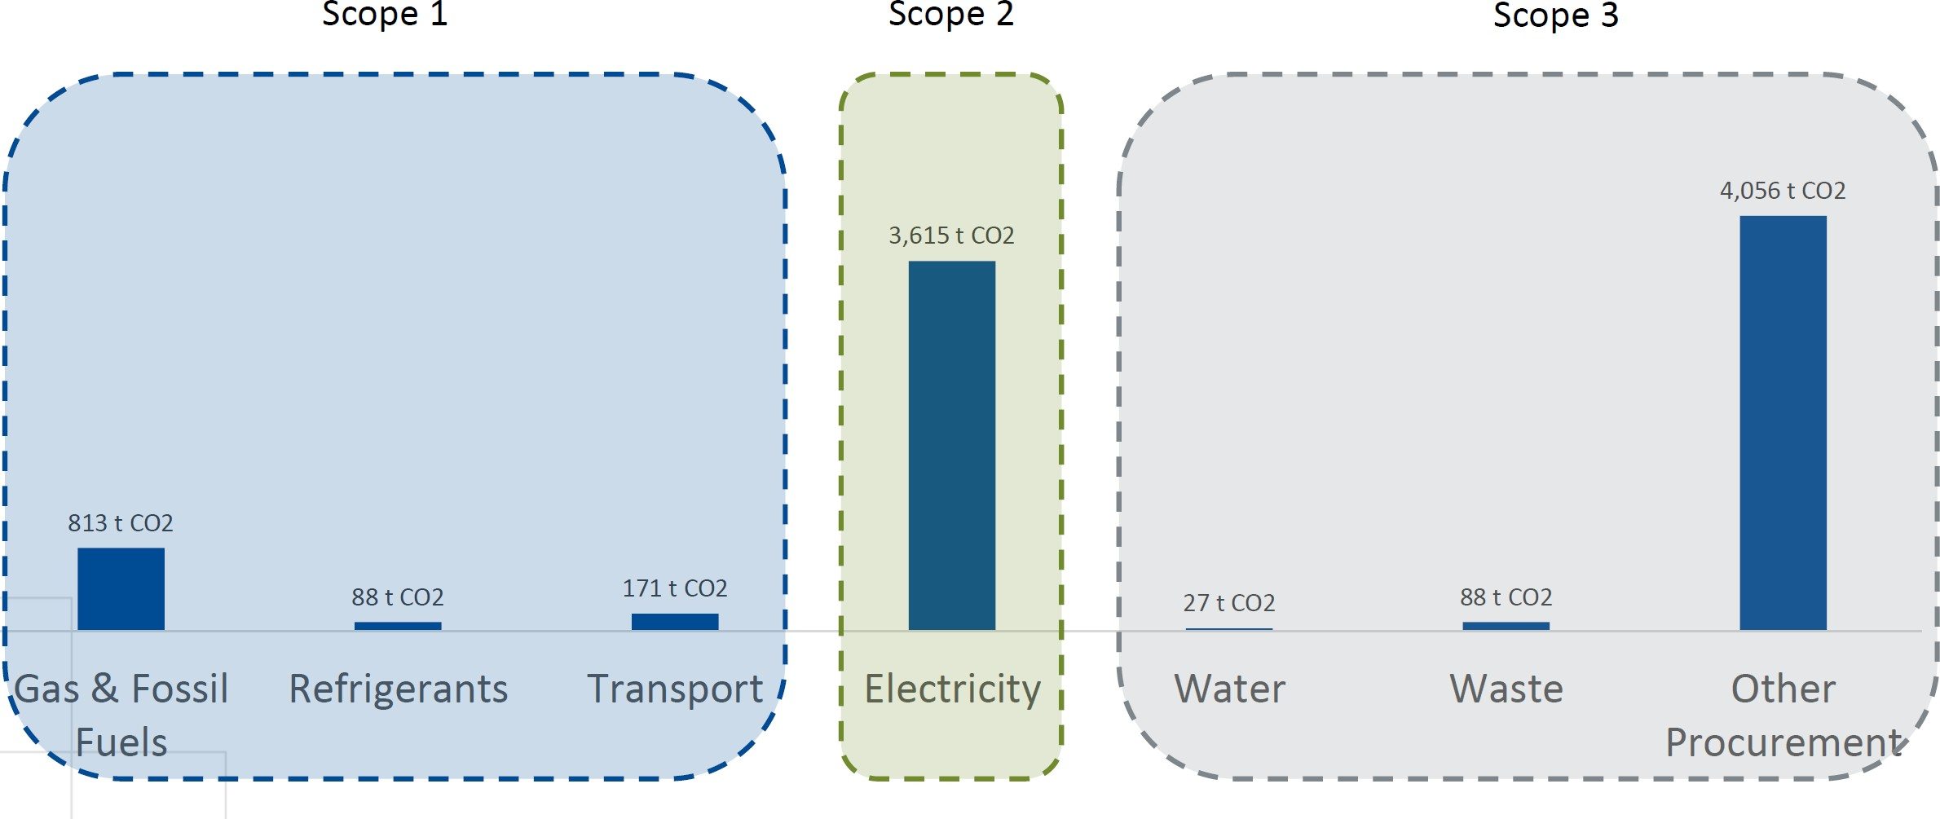
Figure 2: emissions breakdown per category per scope

We can be confident that data for categories like electricity, waste, fuel and water is relatively well quantified through utility bills or waste disposal certificates. However, the category of ‘Other’ has a low level of data quality and more work needs to be done in this space.
Emissions category - ‘Other’
Procurement data has been broken down into categories of emissions, using the financial account code as an indication of the type of goods or services being procured.
Generic emissions as kilograms of carbon dioxide (CO2) per $ (kCO2$) have been assigned to each account code to generate this data. This is considered a low-quality data source, and assessment and reporting on Scope 3 emissions will be improved over time as further advice from the Australian Government is provided.

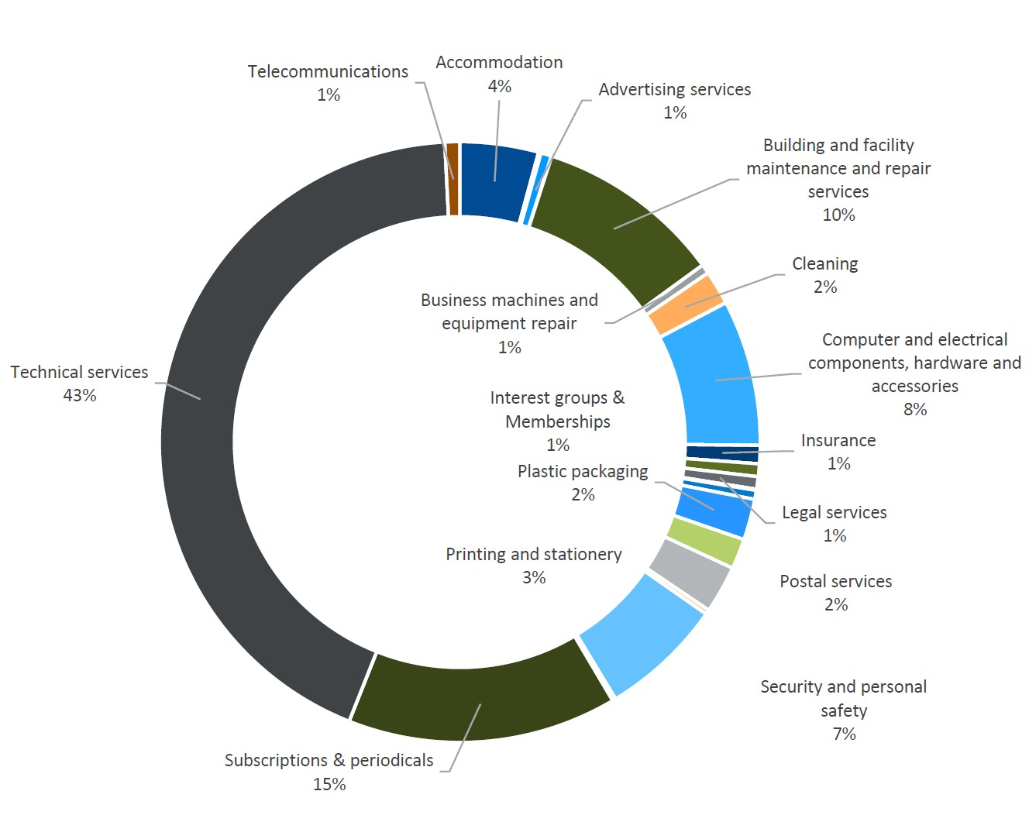
Figure 3 shows the percentage of emissions calculated for each account code in 2023 when establishing the carbon emissions baseline.
Figure 3: percentage of emissions calculated for each account code

The sub-category of ‘Technical Services’ covers contractors/labour hire, capitalised contract costs, and consultants.
The sub-category of ‘Subscriptions and periodicals’ covers:
- Subscriptions – Retrospective.
- Subscriptions – Print.
- Subscriptions – Physical format electronic (CD-ROMs etc).

- Serials – Legal Deposit.
- Subscriptions – eResources.
- Software Maintenance, Subscription, License Fees.

Collection items which come to the National Library through Legal Deposit can be either physical or digital. Further work in understanding the emissions from these deposits and collecting baseline data is required so we can better quantify the emissions and improve our reporting.
Similarly, more research and data collection on digital storage is required so we can establish baseline emissions and identify suitable reduction activities, or ways of offsetting increases in emissions from digital storage and our online digital presence through greater reductions in other categories.
The current total of 10 million physical items in the National Collection comprises paper, metal, film and sound recordings, paintings, fabric, ceramic and furniture. Each of these types has different baseline emissions, and quantifying each type so that emissions can be calculated will require significant effort; however, it will help us identify where further gains in emissions reduction can be achieved.
Donations and acquisitions can be paper or other materials, or a combination of materials in the case of an entire single collection. Collecting the baseline emissions data for these will be another body of work to be done in the next 2-3 years.
Reducing our emissions – the baseline
Figure 4 shows the indicative impact that various activities are expected to have on the overall emissions of the National Library, reducing our emissions by 2030 from 8,858 t CO2 to 2,584 t CO2 and achieving around 70% reduction in emissions by 2030. The remaining emissions will need to be offset until such time as reduction measures are identified and implemented.
Achieving more than 70% reduction in the National Library’s total emissions amount is possible during the next 7 years as the Australia Government’s advice on emissions reduction is refined, the industry’s understanding of greenhouse gas emissions and technology to reduce emissions matures, and we continually review and assess categories such as procurement, capital works, and embedded carbon in the Parkes (ACT) building.
Emissions Reduction Planning
In 2024 the Australian Government released further advice on emissions reduction, including a template for emissions reduction plans (ERP) for use by agencies to outline how they will meet the targets. The National Library prepared an ERP using the recommended template (Version 2.0 dated June 2024).
The Environmental Action Plan is an Attachment to the ERP and sets out the detailed activities the National Library will undertake per category, including the targets outlined in the APS Net Zero Strategy, to reduce its emissions by 2030 (Attachment A).
The ERP and environmental action plan demonstrate how the National Library will meet the APS Net Zero requirements.

Emissions Reduction Plan 2024


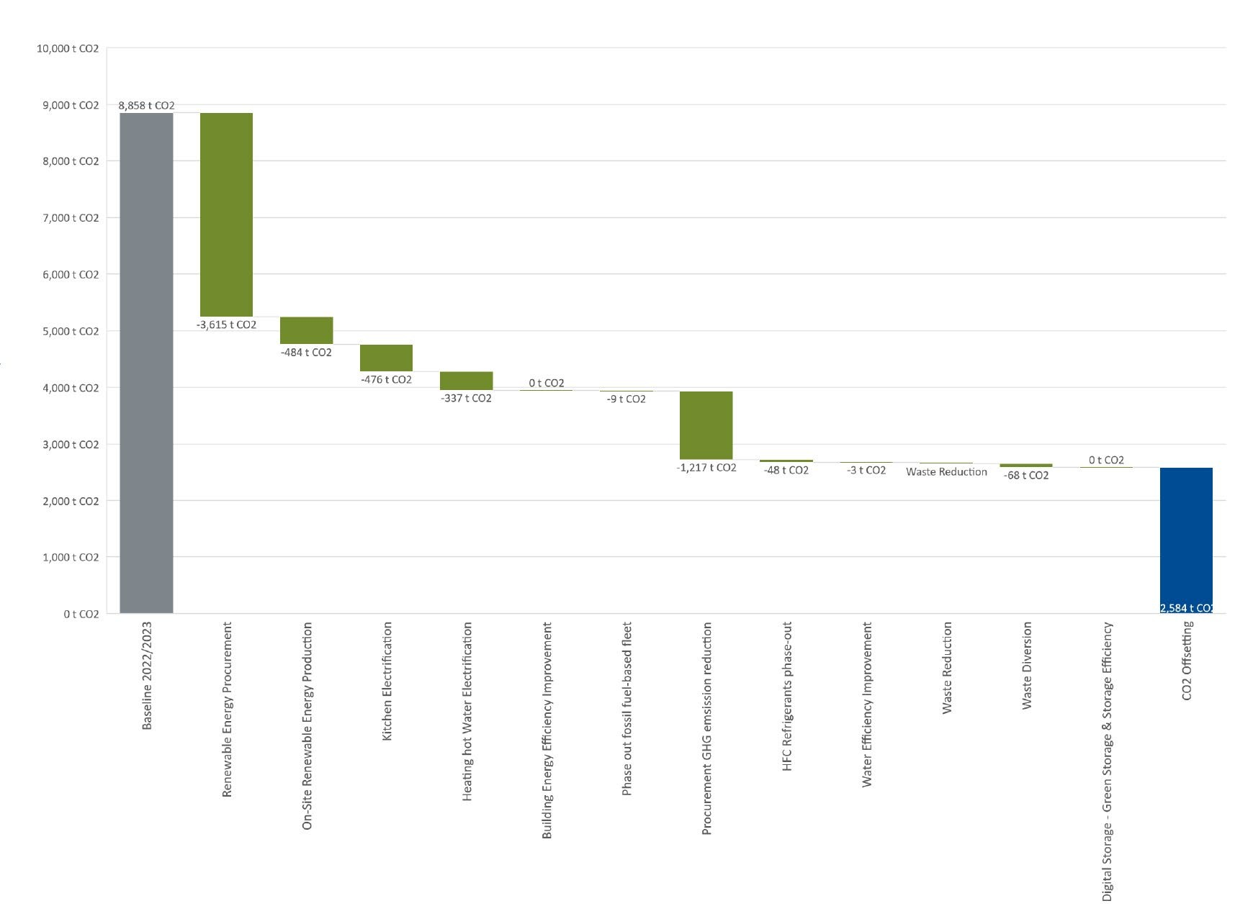
Figure 4: indicative reduction in baseline emissions between 2023 and 2030


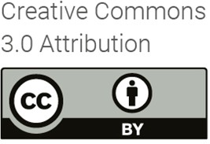
OFFICIAL Page 15 of 17

Emissions Reduction Plan 2024

Attachment A – Environmental Action Plan 2024 – 2030


OFFICIAL Page 16 of 17

Category | Target | High level action | Specific Actions | Responsible Officer / Project | Target Date
Energy | 100% of NLA's electricity | Maximise opportunity for onsite renewable Energy. | Complete a solar PV feasibilty assessment for Parkes (ACT) building especially focusing on:  - Heritage constraints  - Requirements from National Capital Authority  - The actual and predicted electrical load profile  Note that 300-550kW may be feasible on this building. The typical daytime electricity demand for NLA is over 600kW so it is unlikely that significant export would be required subject to final confirmation if Authority limits exits. | Director Facilities and Security (FaS) - Environmental Action Plan | 2024
Energy | 100% of NLA's electricity | Maximise opportunity for onsite renewable Energy. | Complete a solar PV feasibility assessment for Hume Repository, especially focusing on the actual and predicted electrical load profile  Potentially 300kW may be feasible on this building, which is far in excess of the typical demand. | Director Collection Storage - Hume Respository Northern Extension project | 2024
Energy | 100% of NLA's electricity | Maximise opportunity for onsite renewable Energy. | Plan out investment for on-site renewable energy generation projects over a period of 2-5 years, and provide ‘cost assurity’ on level of funding needed. | Director Facilities and Security (FaS) - Environmental Action Plan | 2025 - 2028
Energy | 100% of NLA's electricity | Maximise opportunity for onsite renewable Energy. | Establishment of a solar PV system roll-out plan.  Workforce planning to ensure the library has the capacity to deliver the plan. |  | 2025 - 2028
Energy | 100% of NLA's electricity | Maximise opportunity for onsite renewable Energy. | Deliver solar PV system installations |  | 2025 - 2028
 | renewable energy sources | Aust Government Net Zero target: Procure 100% renewable electricity. | NOTE: ACT already has 100% renewable electricity already in place. | Director Facilities and Security (FaS) - Environmental Action Plan | 2023 - 2030
 | renewable energy sources |  | Whole-of-Australian-Government (WOAG) electricity procurements begin. Entities must procure electricity through these arrangements when in place in their jurisdiction. |  | 2024
 | renewable energy sources |  | WOAG mandatory requirement: 80% of the Commonwealth’s electricity consumption, that is generated off-site and purchased by entities, must be renewable. |  | 2028
 | renewable energy sources |  | WOAG mandatory requirement: 100% of Commonwealth electricity is renewable. |  | 2030
 |  | Plan to upgrade the capacity of the National Library to be able to support renewable energy powered electricity grid. | Review grid-supportive building services strategies, including demand management, energy storage, and other relevant strategies. Identify the level of grid support possible by a facility like the NLA in the context of transitioning to a renewable energy grid.  (Frequency: Every 5 years) | Director Facilities and Security (FaS) - Environmental Action Plan; MSB replacement project | 2024
 |  |  | Complete targeted feasibilty studies for suitable grid-supportive building service strategies |  | 2025 - 2026
 |  |  | Roll-out of the shortlisted grid-supportive building services initiatives |  | 2027
 |  | Progressively implement work to improve the energy effiiciency of the Parkes (ACT) building | Retrofit insulation into building fabric on the envelope of the building. 20% of all spaces complete | Director FaS - EAP project  Roof Refurbishment project (completed) | 2025 - 2026
 |  |  | Retrofit insulation into building fabric on the envelope of the building. 40% of all spaces complete | Director FaS; Director Capital Works | 2025 - 2029
 |  |  | Retrofit insulation into building fabric on the envelope of the building. 60% of all spaces complete | Director FaS; Director Capital Works | 2025 - 2029
 |  |  | Retrofit insulation into building fabric on the envelope of the building. 80-100% of all spaces complete | Director FaS; Director Capital Works | 2025 - 2029
 |  |  | Retrofit windows with insulated glazing units (IGUs) to the envelope of the building. 20% of all spaces complete | Director Capital Works: Windows Refurbishment project (current) | 2024
 |  |  | Retrofit windows with insulated glazing units (IGUs) to the envelope of the building. 40% of all spaces complete |  | 2024
 |  |  | Retrofit windows with insulated glazing units (IGUs) to the envelope of the building. 60% of all spaces complete |  | 2025
 |  |  | Retrofit windows with insulated glazing units (IGUs) to the envelope of the building. 80% of all spaces complete. |  | 2025 - 2026
 |  |  | Retrofit windows with insulated glazing units (IGUs) to the envelope of the building. 100% of all spaces complete | Director FaS | 2025 - 2029

NATIONAL LIBRARY OF AUSTRALIA ENVIRONMENTAL ACTION PLAN 2024 - 2030

Energy consumption is from

Buildings | 10% improvement in EUI (kWh per m2) by 2027 |  | Replace all fluorescent lighting with energy efficient LED type lighting, with energy efficient lighting layout. 60% of all spaces complete | Director FaS | 2025
Buildings | 10% improvement in EUI (kWh per m2) by 2027 |  | Replace all fluorescent lighting with energy efficient LED type lighting, with energy efficient lighting layout. 80% of all spaces complete | Director FaS | 2028
Buildings | 10% improvement in EUI (kWh per m2) by 2027 |  | Replace all fluorescent lighting with energy efficient LED type lighting, with energy efficient lighting layout. 100% of all spaces complete | Director FaS | 2030
Buildings | 10% improvement in EUI (kWh per m2) by 2027 | Improve energy efficiency of the Hume Repository building | Retrofit insulation into building fabric on the envelope of the building.  Replace all fluorescent lighting with energy efficient LED type lighting, with energy efficient lighting layout. | Director FaS.  Director Collection Storage: Hume Repository, northern extension project (current) | 2024
Buildings | 10% improvement in EUI (kWh per m2) by 2027 | Identify other opportunities to reduce energy consumption, through an energy audit program | Create a framework to undertake energy audits (a Type-2, as per AS3598) for Parkes (ACT) building and Hume Repository at a minimum 5 year frequency | Director FaS | 2024
Buildings | 10% improvement in EUI (kWh per m2) by 2027 |  | Complete Energy audits for Parkes building and Hume Repository (Frequency: Every 5 years) | Director FaS | 2025
Buildings | 10% improvement in EUI (kWh per m2) by 2027 |  | Plan out investment in energy efficiency upgrades for the period 2025-2029, and provide ‘cost assurity’ on level of funding needed. | Director FaS | 2025
Buildings | 10% improvement in EUI (kWh per m2) by 2027 |  | Establishment of an energy efficiency initiative roll-out plan.  Workforce planning to ensure the Library has the capacity to deliver the plan. | Director FaS | 2025
Buildings | 10% improvement in EUI (kWh per m2) by 2027 |  | Deliver Energy Efficiency Upgrades | Director FaS | 2025 - 2029
Buildings | 10% improvement in EUI (kWh per m2) by 2027 | Aust Government Net Zero target: Lease and own efficient buildings | WOAG mandatory requirement: Where a lease is entered into for four or more years over an office space of 1000 square metres or more of net lettable area, the office space and the building in which it is located must have and maintain 5.5 star or higher base building and tenancy NABERS energy ratings. | Director FaS | 2025 onwards
Buildings | 10% improvement in EUI (kWh per m2) by 2027 |  | WOAG mandatory requirement: Where a contract is entered by or for the Commonwealth for the purchase or construction of office space with a value greater than $15 million, the office space must have and maintain a 6 star NABERS energy rating and GBCA 4 star Green Star rating (minimum) which includes complying with the Climate Positive pathway. | Director FaS | 2026 onwards
Buildings | 10% improvement in EUI (kWh per m2) by 2027 | Continuously review temperature and humidity requirements for each storage area, to identify opportunities to reduce HVAC energy. | Review each collection to determine adequate temperature and humidity boundaries and identify passive solutions to accommodate a wider temperature and humidity band.  (Frequency: Annually) | Director Collection Care | 2024 - 2029
Buildings | 10% improvement in EUI (kWh per m2) by 2027 |  | Update HVAC controls to suit wider control bands (Frequency: Annually) | Director FaS | 2024 - 2029
Buildings (Electrification) | Eliminate any on-site fossil fuel use by 2027 | Electrification of existing on-site gas powered equipment in kitchens. | Populate an equipment schedule of kitchen gas-powered equipment and their potential electric replacements. | Director FaS | 2024
Buildings (Electrification) | Eliminate any on-site fossil fuel use by 2027 |  | Assess the order of costs for the supply and install of the alternative electric solutions | Director FaS | 2024
Buildings (Electrification) | Eliminate any on-site fossil fuel use by 2027 |  | Roll-out of the equipment replacement | Director FaS | 2024
Buildings (Electrification) | Eliminate any on-site fossil fuel use by 2027 | Electrification of existing gas powered building services equipment. | Populate an equipment schedule of all gas-powered building services equipment and their potential electric replacement. | Director FaS | 2026 - 2027
Buildings (Electrification) | Eliminate any on-site fossil fuel use by 2027 |  | Review key opportunities and constraints relating of each potential concept for HVAC equipment electrification | Director Capital Works: BBS2 Project (current project).  Director FaS. | 2024
Buildings (Electrification) | Eliminate any on-site fossil fuel use by 2027 |  | Establish a timeframe and plan for electrification | Director FaS | 2024
Buildings (Electrification) | Eliminate any on-site fossil fuel use by 2027 |  | Deliver on electrification works | Director FaS | 2025 - 2030
Buildings (Electrification) | Eliminate any on-site fossil fuel use by 2027 | Alternative energy source for Diesel backup for Fire Systems at Hume Repository | Investigate alternative energy options for diesel at Hume. | Director FaS | 2026 - 2027
Buildings (Electrification) | Eliminate any on-site fossil fuel use by 2027 | Alternative energy source for the diesel backup for SCC at NLA | investigate alternative energy options for diesel at Parkes (ACT) building | Director FaS | 2026 - 2027

 |  | Aust Government Net Zero target: Lease and purchase all-electric buildings. | WOAG mandatory requirement: Where a lease is to be entered into for office space, entities should prefer all-electric buildings, particularly if the Commonwealth is directly responsible for base building services costs. | Director FaS | 2024 onwards
 |  |  | WOAG mandatory requirement: Where a contract is entered for the purchase or construction of office space for the Commonwealth, the office space must be all-electric. This includes building heating, cooling and water heating but excludes backup generation, subject to the 2026-27 review. | Director FaS | 2026 onwards
 |  |  | WOAG mandatory requirement: Entities should only lease or own office space that is all-electric. | Director FaS | 2040
ICT | 50% reduction in annual CO2 emission per terabyte of stored data.  20% reduction in EUI for on- site digital storage by 2028.  Be in top 25% of peers for energy use intensity (EUI) using a relevant benchmark, such  as NABERS | Benchmark current on-site and off-site digital storage. | Install sufficient metering to measure the electricity and cooling use of on-site digital storage. | Director FaS | 2024
ICT |  | Benchmark current on-site and off-site digital storage. | Benchmark existing on-site digital storage energy use, both absolute energy consumption and energy consumption per functional unit (appropriate functional unit to be identified).  Benchmark against the NABERS Energy for Data Centres for a comparison against industry peers. | Director FaS CIO | 2024
ICT |  | Benchmark current on-site and off-site digital storage. | Benchmark existing off-site purchased digital storage energy use and emissions. Energy and emissions to be benchmarked as absolute figures, and per functional unit (appropriate functional unit to be identified). | CIO | 2024
ICT |  | Benchmark current on-site and off-site digital storage. | Benchmark emissions profile of existing cloud software subscriptions, where the primary function of the subscription is not storage (i.e. A cloud based editing software that may have digital storage as part of the service, but is not the primary function). Emissions to come from supplier benchmarked data. | CIO | 2024
ICT |  | Optimisation of the on-site and off-site digital storage strategy. | Review and recommend improvements to the equipment selection and operation strategies of on-site digital storage to improve EUI by 20% by 2028 and be in the top 25% of peers for EUI. | CIO | 2025
ICT |  |  | Review options for off-site storage to lower emissions, including:  - revising functional brief to allow for lower energy use storage,  - alternate suppliers with lower energy consumption and/or greater renewable energy supply.  Investigate potential for optional extras from suppliers, including carbon neutral services, tape storage etc. | CIO | 2025
ICT |  |  | Review options for cloud software subscriptions to lower emissions. Investigate potential for optional  extras from suppliers, including carbon neutral services. | CIO | 2025
ICT |  | Aust Government Net Zero target: data centres | New data centre facilities that are sourced outside the whole-of-Australian-Government panel  arrangement, whether owned or leased by the Commonwealth, are required to achieve and maintain 5 stars NABERS Energy for Data Centres or equivalent environmental rating such as a Power Usage Effectiveness of 1.4 or less. | CIO | 2025
Buildings (EV Charging) | Install charging to support fleet and staff electric vehicle use, in all car parks where more than 10 vehicles are expected to park daily, by 2025. | Aust Government Net Zero target: Provide electric vehicle charging facilities | WOAG mandatory requirement: All office space with allocated parking must have an electric vehicle charging plan where possible. | Director FaS | 2024
Buildings (EV Charging) |  |  | WOAG mandatory requirement: Office space with allocated parking should have facilities to support electric vehicle charging where possible, if an entity has electric fleet vehicles on site. | Director FaS | 2025
 | Existing power outlet facility at Service Yard, Parkes (ACT) building to be increased. | Increased outlets at Facilities for greater expansion of existing outlets | Expected growth of use of electric bikes/scooters so this is to accommodate future requirements. | Director FaS | 2025 - 2029
Fleet | Reduce emissions associated with transport of freight and company vehicle use by 50% by 2030. | Review sizing for collections delivery truck | Complete an analysis of the past utilisation of existing diesel truck and predict the future utilisation.  Identify the optimal loading capacity of the truck for the majority of the trips, rather than sizing to accommodate the peak load requirement. Note that third party operators can meet minority of trips requiring a larger loading capacity. | Director Reader Services | 2025
Fleet |  | Aust Government Net Zero target: Overall fleet targets for low emissions vehicles | WOAG mandatory requirement: Target of 25% of new passenger vehicle orders to be low emission vehicles, with a preference for zero emission vehicles. | Director PMO & Procurement | 2023
Fleet |  |  | WOAG mandatory requirement: Target of 50% of new passenger vehicle orders to be low emission vehicles, with a preference for zero emission vehicles. | Director PMO & Procurement | 2024
Fleet |  |  | WOAG mandatory requirement: Target of 75% of new passenger vehicle orders to be low emission vehicles, with a preference for zero emission vehicles. | Director PMO & Procurement | 2025

 | Reduce emissions associated with purchased goods and services, through | Develop and improve environmentally sustainable procurement processes over time | Identify products or services that have similar emissions profiles or environmental impact profiles, and categorise into groups (on the basis that prescriptive 'minimum environmental requirements' can be written that apply to all products and services in a group). | Director PMO & Procurement | 2024
 |  |  | Develop technical specifications for each group of products and services as ‘minimum standards’ to achieve, ensuring lower emissions than typical for that product or service. | Director PMO & Procurement | 2026
 |  |  | For products without a specified 'minimum standard', implement more general sustainable procurement policies to identify products, services and suppliers with sustainable attributes. | Director PMO & Procurement | 2025
Procurement | procurement initiatives and  engaging with key suppliers.  Target of 30% reduction in absolute emissions by 2030. | Aust Government Net Zero target: include environmental sustainability and climate change in procurement practices | Australian Government to develop and publish the Environmentally Sustainable Procurement Policy. | Director PMO & Procurement | 2025
Procurement |  |  | Australian Government to deliver capability uplift for decision-makers to evaluate climate information from suppliers and enhance assessment under the Commonwealth Procurement Rules. | Director PMO & Procurement | 2026
Procurement |  |  | Australian Government to develop the scope 3 cost modelled assessment and work with agencies in its development. | Director PMO & Procurement | 2025
 |  | Quantify emissions from suppliers, and increase accuracy over time. | Build on scope 3 cost modelled assessment to quantify 50% of emissions using supplier specific emissions profiles, rather than cost modelled estimates or industry profiles. | Director PMO & Procurement | 2029
Refrigerants | Reduce and eliminate greenhouse gas emissions from refrigerant leakage and end-of-life disposal. Align with Australian HFC phase- down commitments, by targeting 55% of refrigerant use (by cooling capacity) to be non-HFC in 2030 and 85%  non-HFC in 2036. | Review chillers and heat pumps for new ‘drop- in’ replacement refrigerants with low Global Warming Potential (GWP). | Create a Refrigerant tracker with refrigerant type, quantities and maintenance information for all HVAC equipment operating with refrigerants | Director FaS | 2024 - 2029
Refrigerants |  |  | Market review of drop-in replacement refrigerants (ongoing activity every 5 years) | Director FaS | 2024 - 2029
Refrigerants |  | Replace chillers and heat pumps with lowest possible GWP technology at end of life. | Market review of suitable refrigerants with lowest GWP for chiller and heatpump replacement at end of life (ongoing activity every 5 years) | Director FaS | 2024 - 2029
Refrigerants |  |  | Use information to inform asset life cycle replacement program | Director FaS | 2024 - 2029
Refrigerants |  | Review fridges and freezers (and any other refrigerant containing equipment) and identify replacement technologies with low GWP. Include in the scope of any energy audits. | Create a Refrigerant tracker with refrigerant type, quantaties and maintenance information for miscellaneous equipment operating with refrigerants (e.g. fridges) | Director FaS | 2024 - 2029
Refrigerants |  |  | Market review of suitable refrigerants with lowest GWP for miscellaneous equipment to be considered at end of life replacement (ongoing activity every 5 years) | Director FaS | 2024 - 2029
Refrigerants |  |  | Use information to inform asset life cycle replacement program | Director FaS | 2024 - 2029
Water | Improve water efficiency of the buildings, and thereby reduce emissions associated with water supply, sewage and hot water heating.  10% water consumption  reduction by 2028 | Identify opportunities to reduce water consumption. | Complete a water audit for Parkes (ACT) building and Hume Repository, and benchmark the outcome against the historic performance of the facilities  (Frequency: Annually) | Director FaS | 2024
Water |  | Identify opportunities to reduce water consumption. | Identify possible initiatives and complete a feasibility assessment | Director FaS | 2025
Water |  | Identify opportunities to reduce water consumption. | Deliver the selected initiatives | Director FaS  Director Collection Storage: Hume Repository extension project (current project) | 2024 -2029
Water |  | Identify opportunities to reduce water consumption. | Review use of rainwater or grey water for mechanical equipment and/or heating and cooling | Director FaS  Director capital works | 2024 - 2029
Water |  | Identify opportunities to reduce water consumption. | Complete a feasibility assessment for rainwater use for landscape irrigation or for toilets | Director FaS | 2024
Water |  | Identify opportunities to reduce water consumption. | Deliver the rainwater use initiatives | Director FaS | 2025
 |  | Reduce waste volumes through sustainable procurement policies | Refer to sustainable procurement actions. | Director PMO & Procurement | N/A

Waste | Reduce emissions associated with waste disposal.  Reduce waste generation rates in building works and operation by 20% by 2030.  Target diversion from landfill rates of 80% for for building works and operation. | Implement circular economy initiatives to reuse products and materials that would otherwise be considered at end of life and disposed of. | Develop a 'Materials Recycling and Reuse Plan' template for use on projects, to track kg per m2 waste generation rates on building works project, and percentage of waste diverted from landfill. | Director FaS  Director PMO & Procurement | 2024
Waste |  |  | Implement Materials Recycling and Reuse Plan on pilot project. | Director PMO & Procurement | 2024
Waste |  |  | Include Materials Recycling and Reuse Plan as part of standard building works program. | Director FaS; Director Capital Works | 2025
Waste |  |  | Identify opportunities for recycling and reuse of materials across the Library.  Develop a process for recycling and/or reuse of materials from Library activities and services | Director PMO & Procurement Director FaS | 2026
Waste |  | Reduce amount of waste to landfill through separation and recycling initiatives. | Commission visual waste audit for operational facilities, identifying opportunities to improve diversion from landfill rates. | Director FaS | 2025
Waste |  |  | Track annual waste generation and diversion rates, and put in place triggers for investigation of opportunities. Typically early intervention would be internal review, followed by an audit if underperformance is sustained. | Director FaS | 2025
Embodied Energy – Capital Works | Reduce emissions embodied  in the products and materials supplied through the capital works program. | Develop and improve material purchasing processes over time. | Identify products or services that have similar emissions profiles or environmental impact profiles, and categorise into groups (on the basis that prescriptive 'minimum environmental requirements' can be written that apply to all products and services in a group). | Director Capital Works | 2025
Embodied Energy – Capital Works |  | Develop and improve material purchasing processes over time. | Develop technical specifications for each major type of project delivered as capital works or other major building works programs, outlining requirements to achieve. | Director Capital Works | 2025 onwards
NLA Business Operation areas | Reduce usage of non- environmental materials for housing collections | Phase out use of non-environmental materials in collections | Carry out re-housing and re-packaging audit | Director Collection Care | 2024-25
NLA Business Operation areas |  | Phase out use of non-environmental materials in collections | Implement recommendations from audit | Director Collection Care | 2026 - 2030
NLA Business Operation areas | Review financial investments against Scope 3 requirements | Ensure investments meet Scope 3 requirements | Establish the Scope 3 requirements in relation to investments. | CFO | 2024
NLA Business Operation areas | Review financial investments against Scope 3 requirements | Ensure investments meet Scope 3 requirements | Monitor changes to Scope 3 requirements and implement as appropriate | CFO | 2025 - 2030
NLA Business Operation areas | People, Culture and Capability | Aust Government target: Chief Sustainability Officer role in the organisation, and capability uplift support | Entities are encouraged to identify a Chief Sustainability Officer role within their organisation at an appropriate level and delegation to champion the Net Zero in Government Operations Strategy and related initiatives that support climate action in government operations. | Director FaS | 2024
NLA Business Operation areas | People, Culture and Capability |  | The Department of Finance will support capability uplift across entities, including through advice, guidance, tools, case studies and training programs via the APS Academy. The Climate Action in Government Operations website and GovTeams community will iunclude general information and guidance. | Chief Sustainability Officer and others as required | 2024 - 2030

Emissions Reduction Plan 2024

National Library of Australia
Visit the National Library of Australia website
© Commonwealth of Australia 2024

With the exception of the National Library of Australia logo and all photos and graphics, this report is licensed under a Creative Commons Attribution 4.0 International Licence. Licence is a standard form license agreement that allows you to copy, distribute, transmit and adapt this publication provided that you attribute the work. The Commonwealth’s preference is that you attribute this publication (and any material sourced from it) using the following wording:
Source: Licensed from the Commonwealth of Australia under a Creative Commons Attribution 4.0 International Licence.
To view a copy of this licence visit the Creative Commons website.

Disclaimer:
The Commonwealth of Australia does not necessarily endorse the content of this publication.

OFFICIAL Page 17 of 17

